Poon Hill Trek in January
Poon Hill Trek in January
- Introduction to the Poon Hill Trek in January
- Why Choose January for the Poon Hill Trek?
- Poon Hill Weather in January
- Winter Landscapes and Mountain Views
- Trail Conditions and Walking Experience
- January Trekking Crowd and Tranquility
- Sunrise from Poon Hill in Winter
- Packing List for the Poon Hill Trek in January
- Accommodation Availability in January
- Food and Drinks on the Trail
- Transportation from Pokhara to Nayapul or Ulleri
- Poon Hill Trek Difficulty in January
- Fitness and Preparation Tips
- Guide and Porter Services in January
- Permits Required for the Trek
- Winter Photography Tips on the Trail
- Flora, Fauna, and Nature in Winter
- Safety Tips and Cold Weather Risks
- Local Culture and Villages en Route
- Overview of Poon Hill Trek Itinerary
- Budget and Cost Breakdown
- Other Winter Treks around Pokhara
- Connectivity and Power Backup
- Advantages of Hiking during the Off Season
- Final Thoughts: The Magic of Poon Hill in January
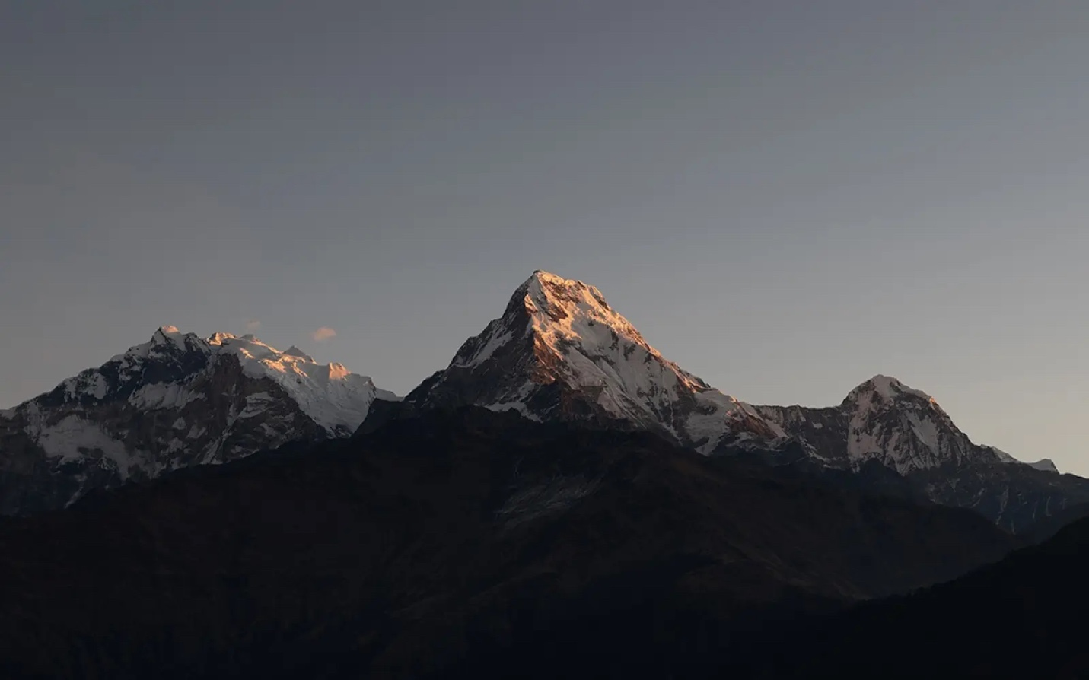
Introduction to the Poon Hill Trek in January
The serene beauty of the Poon Hill Trek in January presents itself with snowy trails, crisp skies, and peaceful Himalayan panoramas.
Indeed, Poon Hill offers a magic Himalayan experience full of tranquility and crisp mountain charm every January. In the Annapurna region, it ascends to Poon Hill (3,210m), one of Nepal's most scenic viewpoints. From here, trekkers see the magnificent Annapurna South (7,219m), Dhaulagiri (8,167m), Machhapuchhre (6,993m), and Hiunchuli (6,441m). The trek begins from Nayapul (1,070m) and goes through Tikhedhunga, Ulleri, and Ghorepani (2,874m) by mixing culture and nature with adventure in a beautiful way.
Moreover, January lends this popular route an exceptionally peaceful atmosphere. The refreshing winter air and the absence of big crowds are a bonus for trekking. Snow often covers the upper parts, transforming Ghorepani and Poon Hill into sparkling white landscapes. Clear morning skies and clear visibility of the mountains make the early sunrise at Poon Hill unforgettable. The sun paints the Himalayas orange and gold shades, reflecting the purity of the season.
Besides that, this trek is recommended for those travelers who prefer a short and moderate winter adventure. The total cost will range from USD 350 to 600, depending on whether trekkers choose either a guided or unguided tour. As for accommodation in January, it remains easily available: cozy teahouses with warm rooms and traditional Nepali meals. Local hospitality feels very genuine, and evenings often include friendly conversations around fireplaces. Real cultural exchange enriches the experience and makes the trek more memorable.
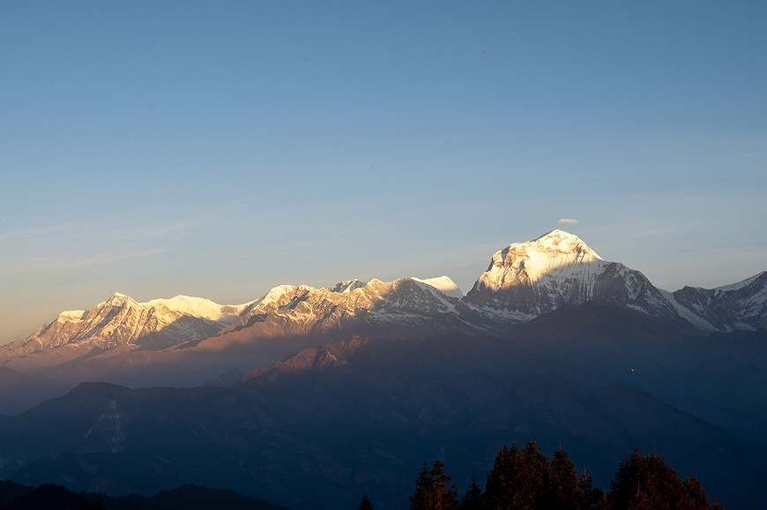
Additionally, in spite of the cold, the walking hours are bearable day to day due to dry winter weather. The average temperature along the route hovers between 4°C and 12°C in the lower villages, while at higher elevations near Ghorepani and Poon Hill, nighttime temperatures usually drop as low as -5°C. For trekking, one should carry warm layers, gloves, and proper footwear to be comfortable. The snow-covered rhododendron forests bear a scenic landscape when set against blue winter skies.
In summary, the Poon Hill Trek in January offers solitude, beauty, and comfort at an easily accessible altitude. The itinerary of 4–5 days suits perfectly for those trekkers who seek magnificent panoramas of the Himalayas but do not want to be challenged with extreme altitudes. With serene trails, low costs, and spectacular sunrises, January turns the Poon Hill Trek into a peaceful retreat in Nepal's Annapurna region.
Why Choose January for the Poon Hill Trek?
Enjoy peaceful trails, crystal-clear skies, and snow-covered scenery of the Himalayas, as January is the ideal period for the Poon Hill Trek.
Indeed, January is one of the most rewarding months concerning peace and visibility for the Poon Hill Trek. After the busy autumn season, the trails around Ghorepani (2,874m) and Tadapani (2,630m) receive hardly any trekkers. Every step becomes enjoyable without the usual crowd; one hears nothing but the crunching of snow underfoot and the chirping of birds that can be heard from a distance. In such a calm environment, it enhances both physical and emotional experiences, drawing one closer to nature.
Likewise, the weather is also stable and clear for most of the month. Cold mornings often bring breathtaking views of Dhaulagiri at 8,167 meters, Annapurna I at 8,091 meters, and Machhapuchhre at 6,993 meters. The sky remains vividly blue, ideal for photography. Because the air humidity is low, mountain visibility extends farther than in other seasons. Sunrise from Poon Hill at 3,210 meters shines brighter against the snow-filled horizon, producing postcard-worthy moments.
Moreover, January offers budget-friendly advantages. Besides, with fewer trekkers, teahouses offer discounts on rooms and food. Accommodation: $3 to $5 per night, meals: $5 to $10 per meal per person. Guides and porters are also more available. One can easily find experienced, quality local support at moderate rates during this time. This helps in boosting the mountain economy during the offseason.
Furthermore, the journey now becomes a real getaway from noise and stress. The tranquil village environment of Ulleri at 2,050 meters and Ghorepani allow trekkers to observe authentic mountain life. Sharing stories with local families near wood stoves, the trekkers experience real Himalayan warmth, not from the weather, but from the people. Fresh air, snow trails, and silent nights offer both adventure and calm reflection.
In conclusion, January is the best time for the Poon Hill Trek because it guarantees a rare combination of tranquility, low cost, and scenic brilliance. The quiet trails, clear skies, and friendly locals provide a surreal journey into the foot of the Annapurna Hills. Winter chill aside, the Poon Hill trek in January might just be one of the most serene and rewarding treks within Nepal's borders.
Poon Hill Weather in January
Poon Hill Trek Weather in January: Temperature, Snow Level, Daylight Hours & Trail Safety Tips
Undoubtedly, the weather will play a vital part in shaping the January Poon Hill Trek experience. This winter month brings cold yet stable conditions, perfect for scenic trekking. In Ghorepani, daytime temperatures reach an average of 4°C to 8°C, with nighttime usually below -5°C. At Poon Hill, the temperature drops to as low as -10°C before sunrise, but the atmosphere is still crisp and dry. Villages down below, like Ulleri at 2,050m and Tikhedhunga at 1,577m, remain comparatively warmer, averaging 8-14°C during the day.
Additionally, snowfall sometimes blankets the upper parts of the trails, mostly between Banthanti (2,250m) and Ghorepani. Light snow enhances the beauty of the trek rather than hindering it. Generally, trekkers experience patches of snow around Poon Hill, adding magic to the early morning sunrise. January sees about 6 to 7 hours of sunshine throughout the day, making comfortable trekking schedules possible even with shorter daylight hours. The clarity of the air provides unbroken views of the Himalayas.
Besides this, humidity is significantly low in January, which ensures stable skies and scarcity of rainfall. Cloudy days are below 10 percent during the entire month. It might be windier at higher altitudes during afternoons, while the mornings are still calm and perfect for trekking. Trekkers should start early to make full use of daylight and enjoy gentle temperatures. Proper gear includes thermal clothes, a down jacket, and waterproof boots, which keep trekkers warm and safe.
Furthermore, the trails remain open, although a bit quieter compared to the peak seasons. The route is well-managed these days, and the local teahouses remain open during winter months. Bringing microspikes or trekking poles is a good idea on icy parts, near Deurali at 2,960m and Poon Hill. Drinking warm liquids and dressing appropriately prevents altitude-related discomfort, even above moderate altitude. The overall experience can be enjoyable, provided the trekkers are prepared for the cold.
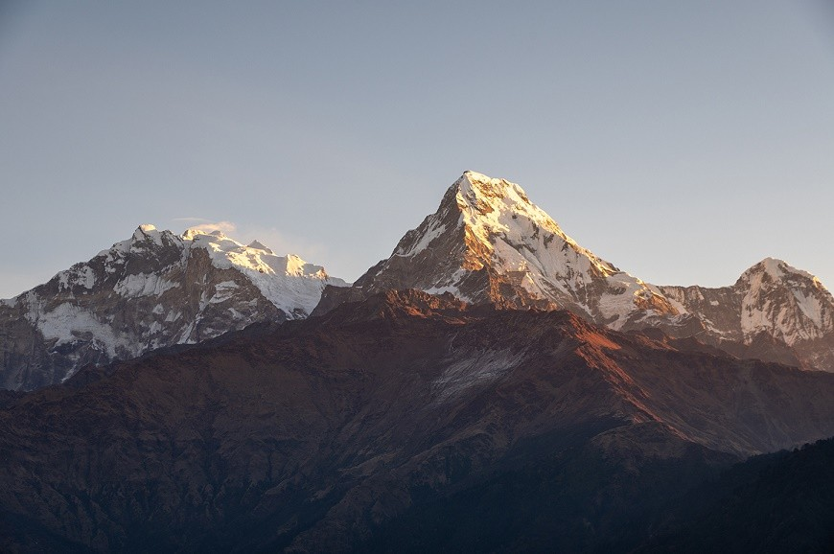
In conclusion, the weather in January on Poon Hill Trek combines cold temperatures with excellent visibility and stability of the skies. The snow-covered trails, glowing sunsets, and refreshing air keep the trekking atmosphere impressive. With proper preparation, January is one of the most peaceful and photogenic months to visit the Poon Hill region of the Annapurna Himalayas.
Winter Landscapes and Mountain Views
Poon Hill in January offers the breathtaking winter landscapes and crystal-clear Himalayan views, showcasing Dhaulagiri, Annapurna, and Machhapuchhre.
Indeed, January turns the Poon Hill area into a vantage point, a snow and sunlight wonderland, at 3,210m. The rhododendron forests of Ulleri, 2,050m, Banthanti, 2,250m, and Ghorepani, 2,874m, shine under fresh frost. As trekkers go up, white-capped ridges surround them, magically contrasting deep blue skies. Every step through the winter landscape feels calm and inspiring, filled with crisp mountain air.
Further, January offers some of the clearest mountain vistas of the year. To the west looms the mighty Dhaulagiri at 8,167 meters, while towards the north lies the Annapurna range, consisting of Annapurna I (8,091 meters), Annapurna South (7,219 meters), and Hiunchuli (6,441 meters). To the east rises the sacred peak Machhapuchhre (6,993 meters), which is known for its vantage fishtail shape. With low humidity and no haze, January allows uninterrupted views of the whole Annapurna and Dhaulagiri ranges. Sunrise from Poon Hill paints these peaks in soft pink and golden hues, offering breathtaking photography moments.
Further, the landscape is enhanced by the snow rather than hindered. The trails between Deurali (2,960m) and Ghorepani sparkle every morning under the sunlight, turning every curve into a scenic frame. The silence of winter accentuates the grandeur of the Himalayas, making it deeply peaceful. The cold air keeps the atmosphere crisp, and trekkers can see distant ridges clearly even in the afternoon.
Beyond this, the winter landscape brings out the cultural charm of local villages: stone-roofed houses covered in snow, smoke rising from kitchen fires, and terraced fields resting under frost add warmth to the cold season. These serene moments along the route make January trekking unforgettable.
In conclusion, the Poon Hill Trek in January promises unrivaled clarity, peaceful ambiance, and snow-framed Himalayan beauty. Vivid sunlight, frozen forests, and majestic peaks make this trek a visual masterpiece for any winter adventurer to witness in the Annapurna region of Nepal.
Trail Conditions and Walking Experience
Poon Hill Trek in January: know all about the trail conditions, which include snow-covered paths, icy stretches, and safe walks.
Naturally, trail conditions during the Poon Hill Trek in January reflect the charm and challenge of winter trekking. The lower part from Nayapul (1,070m) to Ulleri (2,050m) is dry and firm, with occasional frost in the early morning. As trekkers climb toward Banthanti (2,250m) and Ghorepani (2,874m), light snow and icy patches start to appear. The terrain stays well-marked and safe, though careful steps become essential on shaded parts.
Additionally, the snow accumulation around both Deurali (2,960m) and Poon Hill (3,210m) ranges between a few centimeters to ankle-deep layers. In such paths, trekkers would find the path enchanting and a bit slippery. Trekking poles achieve a great deal of improvement in balance, especially early in the morning when the ice is hard. The same applies to microspikes or anti-slip soles on the descending route. The trail is still accessible for trekkers of all levels, given that they have proper preparation and footwear.
Besides, January's firm snow provides stable foothold, unlike the mud-soaked monsoon trails. This crisp air also allows the maintenance of a steady rhythm while trekking. Moreover, no rain means no erosion or slush on the trail. The daytime walking is easier because the sunshine softens the surface but does not melt deep snow. Resting points on Banthanti and Ghorepani have warm tea and shelter, where trekkers rest comfortably before continuing.
Likewise, physical stamina is increased with lesser hours of walking because of limited daylight. One walks on average five to six hours each day, which covers moderate distances with easy ascents. In most cases, porters and guides help update the route and ensure safety on the more snowy stretches. The serene rhythm of walking amidst quiet forests and white peaks injects both adventure and meditation into the experience.
In summary, Poon Hill Trek conditions during January include both calm beauty and manageable challenges. The snowy paths, cold breezes, and stable routes create an ideal winter hiking environment. With basic gear, careful pacing, and proper guidance, trekkers enjoy one of Nepal’s safest and most scenic winter trekking experiences.
January Trekking Crowd and Tranquility
Enjoy peaceful trails and true Himalayan solitude on the Poon Hill Trek in January, away from the autumn and spring crowds.
Definitely, one of the best advantages of trekking to Poon Hill in January includes its exceptional tranquility. The number of trekkers drastically goes down after the vibrant autumn season. Villages including Ulleri (2,050m), Banthanti (2,250m), and Ghorepani (2,874m) receive fewer visitors, and thus personal space is possible and exploration may be done without a rush. Quiet paths let the trekkers absorb the rhythm of nature, hear birds singing, and walk without distraction.
Moreover, this off-season has its advantages of exclusiveness, too. Teahouses overflowing during October and November feel relaxed and spacious in January. Lodge owners have more time to engage in friendly conversations, share stories, and offer warm hospitality. Trekkers can take their meals quietly near the wood stoves without competition for rooms or eating space. It thus engenders a real bonding between travelers and mountain communities.
Additionally, the smaller crowd enhances the natural serenity of Poon Hill’s sunrise viewpoint (3,210m). In other seasons, dozens of people gather before dawn, but January mornings remain calm and open. Trekkers can watch the first light on Dhaulagiri (8,167m) and Annapurna South (7,219m) in silence, capturing photos without obstruction. The peacefulness allows time to reflect, breathe deeply, and appreciate the Himalayas’ grandeur without noise.
In addition, solitude also allows for safety and comfort. With fewer trekkers, trails remain cleaner, and services at teahouses are more personal. Guides fully attend to small groups with much care. Such an environment gives rise to creativity and mindfulness in the minds of photographers and writers. The entire journey turns into not just a trek but a soulful retreat.
Above all, Poon Hill Trek in January is unbeatable for its unmatched peace and authenticity. The lack of crowds, the warmth of local interactions, and the serenity of snowy landscapes will indeed provide a truly meditative experience. Contrasting to busy autumn and spring, January offers trekkers a rare joy of solitude amidst Nepal's majestic Annapurna Himalayas.
Sunrise from Poon Hill in Winter
Enjoy the golden sunrise of winter from Poon Hill in January, illuminating Annapurna, Dhaulagiri, and Machhapuchhre with breathtaking clarity.
Indeed, this view of sunrise from Poon Hill at 3,210 meters in January is considered one of the most spectacular natural sights seen in Nepal. Trekkers who reach the viewpoint well before dawn stand amidst crisp snow and ridges wrapped in silence. The cold air carries a stillness, with only the soft crunch of footsteps breaking the frozen tranquility. The sky changes from indigo to pink as the first light gradually sets the Himalayan peaks aglow in gold.
Furthermore, this winter sunrise reveals a landscape that stretches across two of the world's highest mountain ranges. Dhaulagiri, at 8,167 meters, provides the western anchor, its icy crown ablaze with shades of amber. To the east are seen Annapurna I (8,091m), Annapurna South (7,219m), Hiunchuli (6,441m), and the sacred Machhapuchhre (6,993m). The snow amplifies the light, resulting in sharp contrasts that are a photographer's dream. January skies are crystal clear, so that every ridge and glacier stands out sharply in the image.
Besides, the air is crystal clear, with very low humidity and dust. Trekkers can see much farther than the surrounding peaks, observing deep valleys, frozen streams, and distant ridgelines glowing beneath morning sunlight. The average temperature at the summit before sunrise is around -8°C to -10°C, but the beauty conquers the cold. Warm tea carried from Ghorepani (2,874m) adds comfort as the sun breaks over the horizon.
In addition to, the whole phenomenon appears to be spiritual. The golden rays spread gradually across snowfields, transforming the massifs of Annapurna and Dhaulagiri into radiant walls of light. Every moment is a reflection of peace, power, and gratitude, thus making the trekker emotionally touched. The scene lingers long after one has descended back to Ghorepani, marking one of the unforgettable moments of the Poon Hill Trek.
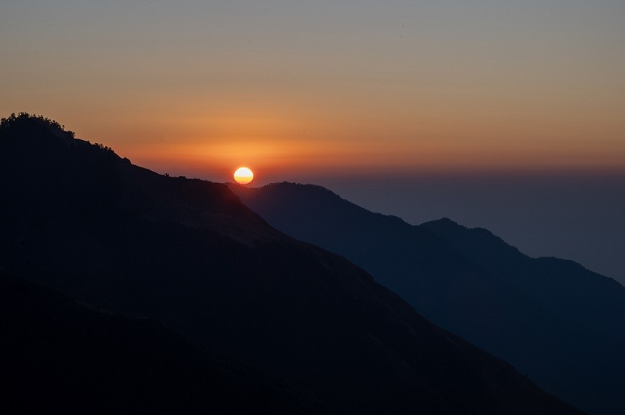
Most importantly, the winter sunrise from Poon Hill is more than a view; it's a revelation of Himalayan majesty. Golden light, snow-capped peaks, and absolute serenity all combine to make January mornings at Poon Hill among the most breathtaking experiences in Nepal.
Packing List for the Poon Hill Trek in January
Get ready for the Poon Hill Trek in January with essential winter gear, such as layering clothes, insulated boots, micro-spikes, and thermal wear.
Naturally, proper packing ensures a safe and comfortable Poon Hill Trek during January's cold weather. Since the temperatures can drop as low as -10°C near Poon Hill (3,210m), layering becomes important. Trekkers should carry warm inner thermals, mid-layer fleeces, and an outer down jacket to keep themselves insulated. The moisture-wicking base layers will help keep the body dry during long walks, and the windproof shells will protect against cold gusts at higher altitudes.
Besides this, one needs proper footwear. Waterproof, insulated trekking boots with good grip are ideal for icy trails. For snow, near Deurali at 2,960 meters and Ghorepani 2,874 meters, trekkers need to attach microspikes or anti-slip crampons. Two pairs of woolen socks, gaiters, and waterproof gloves keep hands and legs warm and safe. A thermal cap, neck gaiter, and sunglasses protect both from cold and snow glare.
Additionally, lightweight yet efficient accessories add to comfort. A trekking pole helps with balance on slippery paths. A high-quality sleeping bag rated for temperatures as low as -10°C assures a night of good rest in unheated teahouses. Portable chargers, headlamps, and a small first-aid kit remain important, as winter daylight is short and power supply limited.
Below is a compact winter packing list for trekkers:
Category | Essential Items
Clothing Layers | Thermal base layers, fleece jacket, down jacket, windproof shell
Footwear | Insulated trekking boots, wool socks, gaiters, microspikes
Accessories | Gloves, cap neck warmer, sunglasses
Equipment | Trekking poles, sleeping bag (-10°C), headlamp, microspikes
Miscellaneous | Water bottle, power bank, sunscreen, small first-aid kit
Besides, carrying refillable bottles saves on plastic and keeps warm fluids at hand. Additionally, trekkers should also bring hand warmers and lip balm to cope with dry cold air. Packing smartly not only guarantees the safety of one but also keeps the rucksack lighter, hence increasing mobility on snow-covered trails.
Conclusion: A well-organized winter packing strategy can ensure warmth and confidence on the Poon Hill Trek. From layered clothing to strong boots and all important accessories, trekkers can make complete use of January's serenity and snow in Nepal's Annapurna region.
Accommodation Availability in January
Get informed about accommodation on the Poon Hill Trek in January regarding teahouse services, heating, food, and booking guidance.
Indeed, January offers both tranquility and availability regarding accommodation on the Poon Hill Trek. Most of the teahouses in Tikhedhunga (1,577m), Ulleri (2,050m), Banthanti (2,250m), and Ghorepani (2,874m) remain open, welcoming winter trekkers warmly. As the crowds thin out after autumn, rooms are easily available even without advance booking. The peaceful environment also allows trekkers to select better rooms at much lower rates.
In addition, accommodation prices in January range from 3 to 5 USD per night. Most of the teahouses provide basic wooden rooms with twin beds, thick blankets, and shared bathrooms. Hot showers may well be available for an extra 2 to 3 USD, depending on altitude and water availability. The dining areas normally become the warmest places because they are warmed up with wood or kerosene stoves. Evenings around these fires make for a friendly atmosphere among the trekkers and the locals.
Similarly, menus are similar for the winter season and include Dal Bhat, noodle soup, potatoes, eggs, and Tibetan bread. Food supplies are not as readily available in January, so one should not rush the preparation of meals at the local eateries. Bringing nuts, chocolate, or energy bars is helpful on days that are longer while trekking. Most of the teahouses allow charging of batteries, although the amount of electricity is minimal on cloudy days.
Below is a quick summary of winter accommodation conditions.
Aspect | Details (January)
Room Availability | High - no advance booking required
Average Cost | $3–5 per night
Heating | Wood/kerosene stoves in dining halls
Hot Showers | Available, USD 2–3
Food Menu | Dal Bhat, noodles, soups, tea, eggs
Electricity | Limited, available at an extra cost for charging purposes only
Additionally, it gives an opportunity to rest in family-run lodges with real hospitality. The locals provide extra blankets upon request and share hot tea to battle the cold. It is important to arrive early to ensure access to the best rooms, which receive direct sunlight. Trekkers should, however, confirm heating availability in higher villages like Ghorepani and Tadapani (2,630m).
In the Poon Hill Trek during January, comfortable and economic lodging in teahouses is offered along with warm hospitality, even though the weather might be cold. The opened teahouses, heated dining rooms, and the locals add to the coziness in this winter trek. This quiet month promises restful nights and personal comfort, adding charm to the Himalayan experience.
Food and Drinks on the Trail
Below, find an overview of the best winter meals, hot drinks, and hydration tips for the Poon Hill Trek in January's cold Himalayan climate.
Of course, food and drinks are a necessity in order not only to restore energy but to keep warm during the Poon Hill Trek in January. Teahouses along Tikhedhunga (1,577m), Ulleri (2,050m), Banthanti (2,250m), and Ghorepani (2,874m) offer a comforting variety of homemade warm meals. Most trekkers start their day with Tibetan bread, porridge, or omelets, often paired with hot tea or coffee. Such breakfasts provide vital carbohydrates and proteins for trekking in cold weather.
Besides, lunch menus generally include Dal Bhat, a traditional Nepalese meal of rice, lentil soup, vegetables, and pickle. Served steaming hot and unlimited, it keeps trekkers warm and energized through the afternoon. Fried noodles, vegetable soups, or momos are other well-liked options. The food is simple but nutritious and fresh, with ingredients found locally to maintain freshness even during winter months.
More importantly, hydration becomes essential despite the low temperatures. The dry mountain air can quickly cause dehydration without noticeable sweating. Trekkers must drink at least three liters of fluids a day. Available everywhere, and which will also help to keep the body warm, are warm herbal teas, garlic soups, and lemon honey teas. Many trekkers prefer carrying insulated bottles so that these will not freeze at higher elevations of Ghorepani and Poon Hill (3,210m).
Likewise, in teahouse kitchens every morning in January, firewood or gas stoves add warmth to restaurants for dining in. The fresh smell of brewed tea and hot soup diffuses through the rooms as trekkers come together for much-needed warmth from stoves. Alcoholic beverages are best avoided as they increase the risk of dehydration in cold weather. Alternatively, ginger and honey teas provide comfort while boosting immunity.
Food and drinks not only help the body but also enhance the trekking experience on the Poon Hill Trek in January. Warm food, steaming soups, and hot teas keep the trekkers comfortable and hydrated during their winter journey. The trek would surely remain healthy and enjoyable amidst the cold Himalayas with proper hydration and proper balance of nutrition.
Transportation from Pokhara to Nayapul or Ulleri
Transportation from Pokhara to Nayapul and Ulleri: Ways to get there for the Poon Hill Trek in January, including road conditions and costs.
Indeed, getting to the starting point of the Poon Hill Trek begins with a drive from Pokhara (827m) to Nayapul (1,070m) or Ulleri (2,050m). This journey covers about 45 kilometers to Nayapul and roughly 55 kilometers to Ulleri. The road follows scenic mountain valleys along the Modi Khola River, passing through fertile farmland and small villages. Choices depend upon comfort, time, and budget.
In addition, local buses from the Pokhara’s Baglung Bus Park make daily trips to Nayapul. They are remarkably cheap, something in the range of NPR 300–500 (USD 3–4). However, they take almost three hours because of frequent stops and moderate road conditions. To travel quicker and more comfortably, trekkers often rent a private jeep for about NPR 8,000–10,000 (about USD 60–75) one way. The jeeps go directly to Ulleri, thereby avoiding a whole day of uphill climbs from Tikhedhunga (1,577m).
Furthermore, the cold weather and occasional snow in January somewhat affect the last part from Hille, 1,430 meters, to Ulleri. Although the roads are open, light snow or frost often makes driving slower near the higher villages. Four-wheel-drive jeeps handle the conditions much better than regular vehicles. It is advisable to hire an experienced local driver for safety and on-time arrival.
Moreover, Public transportation also runs regularly in winter, though morning departures are more certain than afternoon ones. Many comfortable and flexible trekkers share a private jeep with other travelers, which allows them to balance costs and convenience. Options are the same as mentioned earlier while returning to Pokhara and time spent traveling remains about the same.
In the end, transportation from Pokhara to Nayapul or Ulleri is safe and accessible in January. While buses offer affordability, jeeps bring speed and comfort, especially on cold mornings with light snow. It all comes down to the choice of transport for a smooth beginning and ending of this winter trekking adventure to Poon Hill.
Poon Hill Trek Difficulty in January
Understand the difficulty of the Poon Hill Trek in January, regarding cold weather, snow pathways, and walking hours every day.
Naturally, the Poon Hill Trek in January remains a moderately graded trek for trekkers with basic fitness and preparation. The maximum altitude along this route, the top of Poon Hill (3,210m), carries no considerable altitude risks but does bring cold and occasional snow. The main challenge actually comes from steep stone staircases near Ulleri (2,050m) and icy trails between Banthanti (2,250m) and Ghorepani (2,874m). Steady pacing and the use of trekking poles make it easier to maintain one's balance and rhythm.
Besides, the daily walking hours lie around five to six depending on the weather and trail situations. Slightly higher physical strain arises due to winter cold, especially during early mornings and shaded forest paths. The temperatures will get down to -5°C at Ghorepani and at Poon Hill around -10°C before sunrise. Thus, proper layering of clothes and insulated boots become important for comfort and safety. Short daylight hours encourage early starts and consistent walking.
Additionally, snow-covered trails near Deurali (2,960m) can be slippery but can be managed with microspikes or anti-slip soles. The crisp, dry air makes breathing easier, reducing exhaustion compared to humid monsoon conditions. Despite the cold, most trekkers find the Poon Hill Trek in January achievable, even for beginners. Teahouses along the route provide regular rest stops, hot meals, and warm shelters for recovery.
Besides the physical considerations, mental preparation is also essential to ensure success in the endeavor. The winter environment requires patience, slower pacing, and readiness for occasional frost or snow. Carrying enough water and snacks will help maintain your energy throughout the day. Hiring a local guide adds safety if snow should temporarily obscure the path.
All in all, the Poon Hill Trek in January provides moderate physical challenge and tranquil beauty combined. While the cold temperatures and icy trails add some minor difficulties, they also enhance the sense of adventure accomplishment. With proper gear, steady pacing, and mental focus, a trekker would be able to enjoy a rewarding winter trekking experience in Nepal's Annapurna region.
Fitness and Preparation Tips
Prepare yourself for the Poon Hill Trek in January through altitude training, cardio, and winter conditioning to help you have a safe Himalayan adventure.
In fact, the Poon Hill Trek (3,210m) requires an average level of fitness and proper preparation for winter in January. The short trek covers a path already frozen due to the cold weather, and sunrise is very early; thus, it demands physical and mental endurance. Thus, trekkers are supposed to do training at least four to six weeks prior to the commencement.
Likewise, cardiovascular exercises are important for stamina building. Running, cycling, swimming, and stair climbing increase lung capacity, allowing for good oxygen flow; this can be vital at high altitudes. To get in shape, one should consistently take cardio workouts for 30 to 45 minutes and four times a week, which would have a great impact on one's trekking and lessen fatigue in steep climbs.
In addition to, strength training helps your muscles handle long ascents and descents. As for strengthening the legs and core stability, squats, lunges, and planks are three major exercises. Because the trail between Ulleri (2,050m) and Ghorepani (2,860m) features more than 3,000 stone steps, strong legs and knees ensure comfort and prevent injury in icy conditions.
Furthermore, it is equally important to get ready for altitude changes. Though the highest altitude one covers in this trek is modest compared to other Himalayan treks, altitude sickness can affect a beginner. The practice of deep breathing, hydrating regularly, and slow pacing helps the body adjust naturally to rising altitudes.
In addition, winter conditioning is essential in January when temperatures at Ghorepani (2,860m) generally drop below -5°C every night. Acclimatization of the body to chill and altitude can be achieved by training in cold environments, wearing multiple-layer clothes during practice hikes, and testing winter boots. A pre-trek hike in nearby hills with a loaded backpack simulates real trekking conditions.
Besides, physical readiness, mental preparation builds confidence. Winter trekking involves early starts before dawn to witness the sunrise over Annapurna South (7,219m), Machapuchare (6,993m), and Dhaulagiri (8,167m). Meditation, positive visualization, and breathing control help motivate during the journey.
Regarding diet, a balanced meal plan will contribute to endurance. Focus on proteins, complex carbohydrates, and hydration. Alcohol and smoking should be avoided for at least two weeks prior to the trek for better lung capacity.
Finally, packing the right gear completes the preparation: warm clothing layers, waterproof gloves, thermal socks, and trekking poles are paramount for comfort and balance on slippery trails. When trekkers combine fitness training, cold-weather adaptation, and mindful nutrition, they ensure a rewarding and safe Poon Hill experience in January.
Guide and Porter Services in January
Hiring local guides and porters for the Poon Hill Trek in January guarantees safety, cultural insight, and easier travel in snowy Himalayan trails.
In fact, it is practical and beneficial to hire a professional guide and porter for the Poon Hill Trek (3,210m) in January. During winter, snow disrupts the visibility and temperature, which means much support will be required from local experts. Thus, guides with experience ensure not only safety but also cultural understanding and efficiency in the navigation of the trek.
Likewise, licensed guides from either Pokhara (822m) or Nayapul (1,070m) assist trekkers with daily route management, acclimatization, and timing. They are trained to assess conditions on the trail, predict weather changes, and respond when altitude symptoms manifest. Their familiarity with teahouse owners will also help in getting warm lodging during the busy New Year and winter period of trekking.
Similarly, porters are vital in carrying 15–20 kg of luggage, enabling trekkers to walk freely and enjoy scenery. In January, when the paths between Tadapani (2,630m) and Ghorepani (2,860m) might be slippery, the porters help balance the gear, reducing strain on the body and averting possible injury. Their support turns out to be vital during times of heavy snowfall or sudden extreme cold.
Moreover, local guides offer cultural interaction. They share insights about the Gurung and Magar communities, explain village traditions, and translate conversations with locals. This is not only improving the journey but also enables a contribution to the local economy. The hiring of Nepali staff provides a guarantee that tourism benefits rural families dependent on seasonal trekking work.
Additionally, the cost for hiring a licensed guide ranges from USD 25-35 per day, which includes meals and accommodation. A porter costs roughly USD 20-25 per day depending on the load and the route length. Many trekking agencies in Pokhara can provide insured, government-certified staff at fair wages in an ethical and safe fashion.
Besides safety and comfort, having a guide and a porter simplifies logistics: they organize transport, manage permits, and make teahouse bookings in advance. When trails become less visible under snowfall, guides identify correct routes and help trekkers avoid dangerous icy slopes.
Moreover, guides assist in cases of emergencies with the help of local rescue teams or, if necessary, organize the evacuation. Mountain knowledge and first-aid training are very important advantages in places where communication can be challenging, such as Deurali (2,960m) or Banthanti (2,250m).
Finally, hiring locals encourages more responsible travel. It gives rise to cultural exchange, sustains the livelihoods of the local people, and makes trekking possible during the coldest months as well. With their help, a Poon Hill Trek in January would be safer, warmer, and with more meaning for every trekker.
Permits Required for the Trek
Understand the essential trekking permits for the Poon Hill Trek in January: TIMS and ACAP with updated costs and process.
Here, the Poon Hill Trek (3,210m) in January requires obtaining proper trekking permits. Every trekker needs to obtain both the Annapurna Conservation Area Permit (ACAP) and the Trekkers' Information Management System (TIMS) card before the beginning of the journey. These permits help control visitor numbers and ensure trail safety throughout the Annapurna region.
In detail, the ACAP protects the natural and cultural environment across the Annapurna Conservation Area (7,629 sq km). The cost for foreign trekkers is NPR 3,000 (USD 22) per person, while SAARC nationals pay NPR 1,000 (USD 7.50). Trekkers can obtain the permit at the Nepal Tourism Board (Kathmandu) or Tourism Office in Pokhara before heading to Nayapul (1,070m), the usual starting point. Similarly, the TIMS card records trekker details for emergency assistance and safety tracking. It costs NPR 2,000 (USD 15) for individual trekkers and NPR 1,000 (USD 7.50) for those traveling with a guide. The TIMS counter is available in Kathmandu and Pokhara for convenience before heading out.
Moreover, the trekkers have to carry these permits with them during the entire trek because several checkpoints, including Birethanti (1,025m) and Ghorepani (2,860m), check these permits. Keeping both documents accessible ensures smooth passage through conservation zones. Authorities may fine trekkers who fail to present valid permits, so early preparation is essential. It is rather an easy and quick process to obtain permits. Trekkers have to provide two passport-sized photographs, a valid passport copy, and basic trek information: route and emergency contact. If the application is submitted through a registered trekking agency, guides usually handle the process, saving time and reducing paperwork stress. During the month of January, office hours can be shorter because of holidays and cold weather conditions.
For this reason, it is advisable to get the permits one or two days prior to the trek. These agencies can also pre-arrange digital copies in case offices will be closed during weekends. In the context of budgeting, both permits combined approximately cost a solo trekker NPR 5,000 (USD 37) and somewhat less for those going through guided groups. These fees go directly toward maintaining trails, conserving wildlife, and improving local community facilities within the Annapurna region.
In conclusion, permits for TIMS and ACAP are not only legal but also crucial for responsible trekking. Properly acquired, they support the protection of natural beauty, safety, and sustainable tourism in the magnificent Poon Hill area of Nepal.
Winter Photography Tips on the Trail
Capture the beauty of Poon Hill Trek in January with sunrise photography tips, keeping batteries safe from cold temperatures, and preventing fog in lenses for the best winter pictures.
Actually, the Poon Hill Trek of 3,210m in January offers dreamlike photography conditions: snow-dusted trails, clear skies, and glowing Himalayan peaks all combine in breathtaking compositions. Trekkers should thus prepare for the right timing, gear care, and winter techniques that will capture crisp, luminous images.
Moreover, the most iconic moment: the sunrise from Poon Hill (3,210m).Photographers should begin in the pre-dawn hours from Ghorepani (2,860m) and reach the viewpoint by 5:30 a.m. The first light hitting Annapurna South (7,219m), Dhaulagiri (8,167m), and Machapuchare (6,993m) paints them golden and pink. Setting up early ensures the best angle before the crowd arrives.
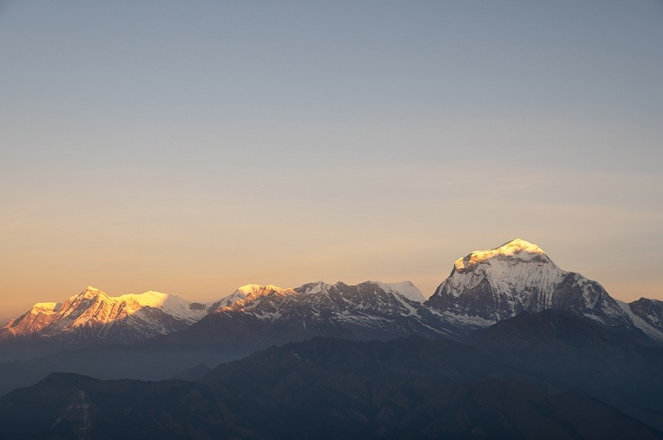
Furthermore, the trek from Tadapani (2,630m) to Deurali (2,960m) also offers spectacular forest and valley views. The rhododendron trees laden with snow act as natural frames for your landscape shots. As far as possible, use a tripod for stability and keep ISO low to preserve image clarity in low-light conditions.
Actually, this is the point when battery management becomes crucial. Winter air sucks a lot out of power resources, particularly below 0°C. Therefore, extra batteries should be carried by trekkers, which they should keep near the body in inner pockets to keep them warm. Rotating batteries during rest breaks prevents them from fully discharging on the trail.
In addition, condensation and lens fog are common challenges when moving between warm teahouses and cold outdoors. For this reason, place your camera in a sealed plastic bag before entering a warmer room and let it gradually attain the temperature. Microfiber cloths come quite handy in cleaning off snow or moisture from the lenses without scratching them.
As far as settings are concerned, exposure in RAW format preserves the detail and flexibility for post-editing. Using exposure compensation of +1 or +2 avoids underexposed snow scenes, while white balance needs to be set manually for accurate tones against the dazzling white background.
Below is the short reference chart for photographers:
Condition | Best Technique | Recommended Gear
Sunrise view (Poon Hill) | Arrive before 5:30 a.m., use tripod | DSLR or mirrorless with 18–55mm lens
Snowy forest (Tadapani–Deurali) | Use low ISO, wide aperture | Polarizing filter, tripod
Low temperature | Keep batteries warm | Extra lithium batteries
Lens fog | Control temperature transition | Plastic bag and microfiber cloth
Finally, gear protection from moisture should always be done with waterproof covers or dry bags on the camera. With careful planning, early timing, and cold-weather care, photographers can capture pristine Himalayan beauty throughout the Poon Hill Trek in January.
Flora, Fauna, and Nature in Winter
Discover the serene winter nature of the Poon Hill Trek with quiet rhododendron forests, rare bird sightings, and snow-covered Himalayan scenery.
To begin with, January turns the Poon Hill region (3,210m) into a peaceful snow and silence wonderland. The trail takes one through forests, frozen streams, and high ridges, unfolding the quiet rhythm of Himalayan winter. Though many plants go dormant during this season, nature remains vibrant in gentle and captivating ways.
Further, the rhododendron forests that define the Annapurna region (7,629 sq km) lie dormant in January. The green leaves glisten under frost, and the trees form striking white tunnels between Ulleri (2,050m) and Ghorepani (2,860m). Though the bright red blooms appear in spring, their sculptural branches offer artistic winter contrast against the snow.
In addition, the trekkers often notice evergreen oaks, magnolias, and bamboo groves retaining color down below. These plants mark vital cover for wildlife that remains active even in this cold. The forest heaves with life under the shroud of snow as far as one can see.
Moreover, birdwatchers find the month of January surprisingly rewarding. Species like the Himalayan monal, magpies, and sparrows forage near open ground. Their colored feathers bring movement and color to otherwise still landscapes. The best chances of spotting and photographing them are during dawn hours around Deurali (2,960m) or Tadapani (2,630m).
Besides, trekkers can see animal tracks imprinted on snow, proof of elusive species like musk deer or langurs exploring quiet paths. The signs remind visitors about the deep natural balance that exists even when the human presence fades during winter.
Additionally, the air is crystal clear in January, offering brilliant views of Annapurna South (7,219m), Hiunchuli (6,441m), and Dhaulagiri (8,167m). Unlike in summer, haze seldom upsets visibility. Therefore, each step unveils breathtaking contrasts between darker forests and gleaming peaks.
Furthermore, the peaceful environment heightens the spirituality of trekking. With few travelers, trekkers hear the wind through pine trees and snow crunching below their feet. It connects a trekker with the Himalayan wilderness.
The following are some tips that can be followed by trekkers for environmental preservation:
- Stay on marked trails to avoid damaging frozen vegetation.
- Carry waste back to Pokhara or to the various disposal points.
- While photographing, avoid disturbing the birds or wildlife.
In winter, nature on the Poon Hill Trek shows quiet endurance rather than vibrant bloom. Resting flora, resilient fauna, and the crystal-clear atmosphere reveal a softer, purer side of the Annapurna region that stays etched in every trekker's memory.
Safety Tips and Cold Weather Risks
Have a safe Poon Hill Trek in January with the prevention of frostbite and awareness of hypothermia, along with key cold-weather precautions for winter trekkers.
Actually, Poon Hill, at an elevation of 3,210 meters, will require strict attention to cold-weather safety in January. Overnight temperatures below -10°C and icy trails challenge even the experienced trekkers. For this reason, preparation and awareness against serious winter health risks become important.
In fact, frostbite is the chief concern at high-altitude cold, which can damage fingers, toes, the nose, and ears during periods of prolonged exposure. Trekkers need to wear insulated gloves and woolen socks, besides windproof outerwear. The extremities need to stay warm and dry at all times to avoid any tissue injury.
Similarly, hypothermia results from a drop in body temperature because of prolonged exposure to cold. Early symptoms include shivering, dizziness, and confusion. Wherever possible, trekkers should wear multiple layers of clothes and keep dry to prevent putting on soggy clothes in freezing air.
The following table summarizes major risks and preventive actions.
Risk | Possible Cause | Prevention Tips
Frostbite | Skin exposed to cold wind | Wear insulated gloves and socks; keep the extremities warm
Hypothermia | Wet clothes, exhaustion | Layer up, change damp clothes quickly
Slippery Trails | Ice or snow accumulation | Use trekking poles, microspikes
Altitude Sickness | Rapid ascent | Ascend slowly, stay hydrated
Also, proper hydration is necessary, even in cold conditions. Dehydration can weaken circulation and increase susceptibility to cold. It is recommended that trekkers use insulated bottles to prevent the freezing of water above Ghorepani (2,860m). Carefully walking on icy sections minimizes the risk of slips and falls. Trekking poles and microspikes give stability. Starting early in the morning ensures completion of daily routes before temperatures fall sharply after sunset.
Equally importantly, proper rest helps maintain body strength. The cold consumes extra energy, so trekkers must take in hot, carbohydrate-rich meals at teahouses. Foods like soup, porridge, and rice curry restore warmth and give energy for the next day's climb.
In addition, communication plays a vital role in winter trek safety: guides monitor the weather conditions and decide whether to stop or to continue. Also, trekkers should notify teahouses about their next destination every evening.
Finally, understanding one's limits and acting cautiously ensures safety throughout the trek. When properly equipped, hydrated, and layered, trekkers can enjoy the snowy landscapes of Poon Hill Trek comfortably while still being safe from all hazards presented by winter.
Local Culture and Villages en Route
Discover the warm village culture along the Poon Hill Trek in January, from Ghorepani to Ghandruk, and experience authentic Himalayan winter life.
Actually, the Poon Hill Trek (3,210m) is a trek that passes through some of Nepal's most charming villages. Even in January, when snow has enveloped the trails, the life of the locals goes on with the same warmth and reception. The trail meanders through Ulleri (2,050m), Ghorepani (2,860m), and Ghandruk (1,940m), giving you an idea of the day-to-day rhythm of Gurung and Magar culture.
First, Ulleri (2,050m) greets the trekkers with traditional stone houses and terraces of fields. Villagers, though affected by winter chills, are busy doing household work, rearing animals, and collecting firewood. The air is frequently filled with the burning pinewood aroma, and generally, trekkers enjoy warm dal bhat and local millet wine in the evening.
Moreover, lifestyle becomes slower yet resilient as trekkers go up to Ghorepani (2,860m). In January, roofs are coated in snow, and the whole village sits around fireplaces telling tales. People run family teahouses serving hot meals and offering shelter to trekkers, which is indeed very famous and warm with an amiable atmosphere; even the chilliest evenings become warmly pleasant because of the hospitality of the locals.
Similarly, Ghandruk (1,940m)—one of the largest Gurung settlements—shows vibrant culture and traditional architecture. The village hosts smaller community gatherings and religious rituals at local temples during winter. Visitors can explore the Gurung Museum that showcases ancient tools, ornaments, and cultural artifacts reflecting Himalayan heritage.
In addition, winter lends a serene rhythm to village life. Children go to the local schools despite the chill, while the elderly sit by windows weaving wool or chatting over tea. Without large tourist crowds, trekkers can have personal interactions with villagers and experience their culture and farming practices.
In regard to food culture, organic produce such as lentils, rice, potatoes, and vegetables stored for the cold seasons are served in local teahouses. Homemade butter tea or ginger honey tea helps combat the mountain cold. These flavors reflect the simplicity and richness of Himalayan living.
In all, Poon Hill is not only about snowy landscapes, but it's about the warm-hearted people of this place. Winter trekking reveals the authentic lifestyle of Gurung and Magar families, keeping the mountain spirit alive at freezing temperatures. Their resilience and kindness make every stop a memorable cultural experience.
Overview of Poon Hill Trek Itinerary
Discover the ideal 5-day winter itinerary for the Poon Hill Trek in January. Highlights, elevation, and scenic Himalayan viewpoints will be covered.
First of all, Poon Hill Trek (3,210m) is a short and rewarding adventure that fits just fine in January when the Himalayas shine under snow. The route passes through beautiful villages, rhododendron forests, and panoramic viewpoints while staying below risky altitude levels. The following itinerary provides a comfortable winter schedule.
Day 1: Pokhara (822m) to Nayapul (1,070m) – Trek to Ulleri (2,050m)
Drive from Pokhara for about 1.5 hours to Nayapul. Start the trek through Birethanti (1,025m) and ascend steep stone stairs to Ulleri. Overnight at a local teahouse.
Day 2: Ulleri to Ghorepani (2,860m)
The track cuts through oak and rhododendron forests covered in light snow. Ghorepani provides a warm overnight stay in preparation for the sunrise hike up Poon Hill.
Day 3: Hike to Poon Hill (3,210m)–Trek to Tadapani (2,630m)
Start pre-dawn to see the sunrise view of the Annapurna (8,091m), Dhaulagiri (8,167m), and Machapuchare (6,993m). Descend down to Ghorepani for breakfast and head to Tadapani through beautiful forests.
Day 4: Tadapani to Ghandruk (1,940m)
Descend through rhododendron trees to the Gurung village of Ghandruk. Visit the museum and enjoy views ofAnnapurna South (7,219m) and Hiunchuli (6,441m).
Day 5: Ghandruk to Nayapul – Drive back to Pokhara (822m)
Walk down to Kimche (1,640m)or Syauli Bazaar (1,220m) and take a jeep back to Pokhara. The trek ends with a relaxing evening by Phewa Lake (822m).
This itinerary suits all fitness levels and provides ample acclimatization for moderate winter trekking. With proper clothing and an early start, trekkers can enjoy a smooth and scenic January adventure in the Annapurna region.
Budget and Cost Breakdown
Plan your Poon Hill Trek in January, including a full breakdown of costs for permits, transport, guide, food, lodging, and gear rental.
First of all, the Poon Hill Trek (3,210m) is among the most budget-friendly treks in Nepal, even in January. While winter adds small expenses for gear, overall, the costs remain very moderate and affordable. The estimated cost for a 5-day trek from Pokhara ranges from USD 350–550 per person.
Moreover, accommodation in teahouses costs about NPR 500–800 (USD 4–6) per night, inclusive of blankets and basic heating. Dal bhat, pasta, and soup are some of the typical dishes available at NPR 700–1,000 (USD 5–8) per dish. On average, trekkers spend about USD 25–30 per day on food and lodging.
Similarly, Transportation between Pokhara and Nayapul generally starts at about NPR 2,000–3,000 (USD 15–22) for a private jeep and USD 3–5 by local bus. During winter, a private jeep is preferred for safety and flexibility.
Below is a summary of average costs:
Category | Estimated Cost (USD) | Remarks
ACAP Permit | 22 | Mandatory
TIMS Card | 15 | Mandatory
Accommodation | 25–30 in total | 4–5 nights
Meals | 125–150 | Dal bhat, soups, noodles
Tour Guide | 25–35 per day | Licensed and insured
Porter | 20–25 per day | Optional but helpful
Transport | 15–25 | Round trip Pokhara–Nayapul
Gear Rental | 20–40 | Sleeping bag, down jacket
Furthermore, hiring a guide and porter boosts safety and convenience in snowy days, especially. Their package includes food and accommodations. Equipment rentals in Pokhara save rather expensive new gear purchases.
On average, guided trekkers spend around USD 500, whereas independent trekkers can get by with approximately USD 350. This cost ensures comfort, warmth, and safety in one of Nepal’s most accessible Himalayan treks.
Other Winter Treks around Pokhara
Actually, the best alternatives for winter treks near Pokhara are Dhampus, Australian Camp, and Mardi Himalfor short, scenic January adventures. The region around Pokhara (822m) has several excellent alternatives for the Poon Hill Trek (3,210m) in January. These routes are open all year, have gentler elevations, and yet equally spectacular Himalayan views. They're thus ideal additions for trekkers looking for something shorter or quieter this winter.
First is the Dhampus Trek (1,750m), which is a tranquil two-day hike from Phedi (1,130m). The route meanders upwards through forests and terraced fields to the village of Dhampus, with breathtaking sunrise views of Annapurna South (7,219m)and Machapuchare (6,993m). For the most part, the trail remains free of snow during most of January and is good for families and first-time trekkers.
Second, the Australian Camp Trek (2,060m) provides panoramic mountain views in a very short period. Trekkers can get to the camp from Kande (1,770m) within two hours of trekking. In winter, this offers clear skies and cozy lodges with breathtaking sunset views over the Annapurna range without extreme cold.
Further, Mardi Himal Trek (4,500m) attracts those who would rather trek with less crowding for a more moderate adventure. The trail ascends smoothly from Kande (1,770m) via Forest Camp (2,550m) and High Camp (3,580m) to the Mardi Himal Viewpoint (4,200m). In January, trekkers experience snow above 3,000m but enjoy exceptional clarity and solitude.
Below is a short comparison of winter treks near Pokhara.
Trek | Max Elevation (m) | Duration (Days) | Highlights
Dhampus Trek | 1,750 | 2 | Easy, cultural, family-friendly
Australian Camp Trek | 2,060 | 2–3 | Mountain views, short route
Mardi Himal Trek | 4,500 | 5–7 | Snow, solitude, alpine scenery
In the end, each of them provides a unique experience with safe access and exceptional views in January. Be it the short, cultural Dhampus route or the adventurous Mardi Himal climb, winter treks around Pokhara guarantee some unforgettable Himalayan beauty without extreme conditions.
Connectivity and Power Backup
Stay connected during the Poon Hill Trek in January, and find out about phone signal, Wi-Fi, and battery backup that keeps your devices functional during the winter season.
First of all, connectivity on the Poon Hill Trek-3,210m is rather limited, yet manageable for basic communications. Mobile signals vary with altitude, weather conditions, and the network provider. Therefore, trekkers need to plan on minimal coverage, bringing local SIM cards or using an offline map of their route for navigation.
Similarly, major villages like Ulleri, Ghorepani, and Ghandruk often have stable 3G or 4G coverage, while higher viewpoints like Poon Hill may receive intermittent signals due to the mountainous terrain. One must, of course, take care to inform the family back home and guides of where and when communications may not be possible.
Moreover, most of the teahouses along the route offer Wi-Fi access. Ghorepani and Ghandruk offer Wi-Fi for 1-3 USD per hour, but this is very slow and cannot be used for video calls. It is best to always inform your teahouse in advance if you need this connection, especially if traveling in January when fewer tourists visit the region.
Further, it is very important to manage the battery in cold conditions. Winter temperatures below 0°C drain the batteries of smartphones and cameras very fast. Therefore, trekkers should bring extra camera batteries and phone power banks. Keeping batteries inside your inner jackets or putting them in thermal pouches can work to insulate them from cold.
Besides, solar chargers provide a great backup in those places where facilities are remote. January skies are clear in winter; the time between 9 am and 3 pm is best for effective solar charging. Trekkers can use portable solar panels to recharge small devices without relying solely on teahouse outlets.
Below are key tips for maintaining connectivity and power during winter trekking:
- Bring two fully charged power banks of at least 10,000–20,000 mAh each.
- Keep devices close to the body in order to avoid cold discharge.
- Limit unnecessary application usage in order to save the battery.
- Use Airplane Mode when not communicating actively.
- Verify availability of Wi-Fi during overnight stops for backup internet.
Finally, trekkers should embrace the limited connectivity as part of the Himalayan experience. While technology may falter, the uninterrupted views of Annapurna South (7,219m), Hiunchuli (6,441m), and Dhaulagiri (8,167m) reward those who disconnect. With careful battery management and offline preparation, staying connected while enjoying the winter trek is completely doable.
Advantages of Hiking during the Off Season
Advantages of the Poon Hill Trek in January include solitude, clearer views of the Himalayas, and authentic local experiences.
Actually, the first and foremost reason is that there are unparalleled advantages to trekking Poon Hill Trek (3,210m) in January compared with peak seasons. The trail is quiet, the views are clearer, and the interactions with the locals are much more genuine. Off-season trekking allows visitors to enjoy the Himalayan environment without crowds, enhancing both the scenery and the cultural experience.
Likewise, the advantages include solitary silence: fewer tourists travel to villages like Ghorepani (2,860m), Tadapani (2,630m), and Ghandruk (1,940m) in January. The trekkers can take part in the rhythm of village life, from morning fires to evening storytelling, without interruptions. This quiet atmosphere enhances reflection and personal connection with nature.
Besides, the breathtaking views of the mountains become crystal clear in winter. The cold temperature decreases haze, showing the full glory of Annapurna South (7,219m), Machapuchare (6,993m), and Dhaulagiri (8,167m). Sunrise from Poon Hill (3,210m) becomes golden and sharply outlined, making photography and sightseeing exceptional during this off-season.
Moreover, cultural exchanges become more personal. The local owners of teahouses and villagers have time to speak with trekkers, sharing stories, traditional meals, and knowledge about Gurung and Magar customs. Winter trekking fosters deeper interactions that might be rushed or skipped over during more popular periods.
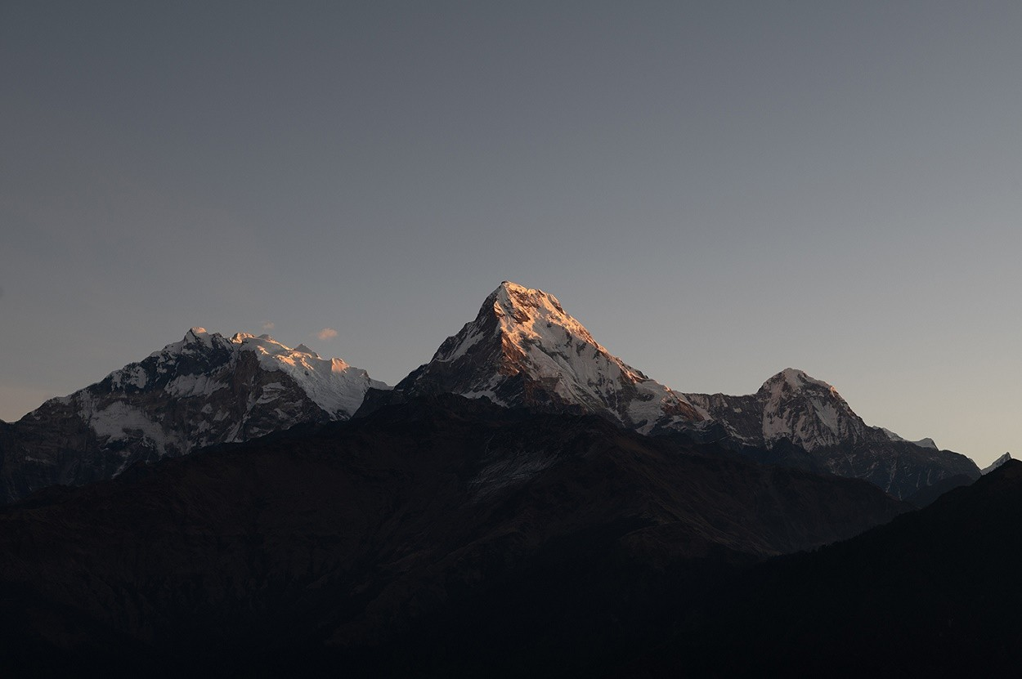
Additionally, another benefit of Poon Hill Trek in January involves trail conditions. While the trails in January may be snowy, they are less crowded, minimizing wear and erosion. The absence of mass tourism allows trekkers to comfortably navigate stone steps, forest paths, and ridges, even on icy mornings.
Likewise, trekking during the off-season builds resilience and adventure skills. Handling cold, planning for limited resources, and adapting to quieter villages instill confidence in any future Himalayan treks. Besides that, it offers a kind of exclusivity whereby travelers witness landscapes untouched by many during the spring and autumn seasons.
In addition to, this quiet time for January trekking means solitude, clear visibility, an emersion into culture as well as many adventurous challenges. These benefits make the off-season Poon Hill Trek quite rewarding and memorable for travelers seeking authentic Himalayan encounters.
Final Thoughts: The Magic of Poon Hill in January
Poon Hill Trek in January offers an experience with trails of snow, serene villages, golden sunrises, and tranquil winter landscapes of the Himalayas.
Poon Hill Trek-3,210m: The magic of the Himalayas begins right here in January. It is a month that brings snow silence, frosted forests, and crisp winter air, which creates an unforgettable atmosphere in each step through tranquil landscapes where nature seems untouched, pure, and fresh.
Firstly, the sunrise from Poon Hill (3,210m) captures the heart of every trekker. The golden light illuminating Annapurna South (7,219m), Machapuchare (6,993m), and Dhaulagiri (8,167m) transforms the mountains into a breathtaking spectacle. Observing this natural wonder evokes awe, reflection, and deep appreciation for the Himalayan environment.
Further, the quiet villages along the trail, Ulleri (2,050m), Ghorepani (2,860m), and Ghandruk (1,940m), add warmth to the cold during winters. Smoke rising from chimneys, traditional teahouses, and smiling locals give a cultural depth to the journey. Trekkers feel the blend of human life with nature in perfect harmony.
Additionally, the snow-covered rhododendron forests, frozen streams, and panoramic ridges create serenity and solitude. Absence of tourist crowds allows moments of reflection and personal connection with the mountains. Walking in January is almost meditative, with only the crunch of snow underfoot and distant birdcalls breaking the silence.
Besides, the clear skies of winter further heighten visibility across the Annapurna range. Every viewpoint offers vivid panoramas, and photography, sketching, or simply observing the peaks can be an emotional experience. Chilly mornings and cool evenings heighten this sense of wonder, as the light of the Himalayas paints the landscape in surreal colors.
Finally, the mixture of natural beauty, quiet villages, and off-season tranquility creates lifelong memories. The Poon Hill Trek in January is a journey into the heart of the Himalayas, where mountains, culture, and peace meet. The golden sunrises, serene paths, and snowy silence imprint a sense of calm and fulfillment that stays with every trekker long after the journey ends.
In conclusion, trekking Poon Hill in January is not just a winter adventure but also an emotional, spiritual, and aesthetic experience. This short trek becomes timeless in the memory of all those visiting due to magic created by snow, solitude, and golden light of the Himalayas.
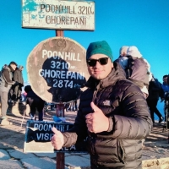
Author
Krishna Thapa

