Poon Hill Trek in February- Weather Guide and Trail Condition
Introduction: Why Trek Poon Hill in February

Haven Holidays Pvt. Ltd.

Enjoy the cool serenity and snow-capped peaks this February trekking along Poon Hill at 3,210 meters. Find out here about quiet trails, clear mountain visibility, and fewer crowds. Start planning your perfect winter Himalayan getaway.
Indeed, trekking to Poon Hill at 3,210 meters in February offers a rare blend of serenity and spectacular mountain vistas that few months can match. The trails are tranquil, the skies crisp, and the panorama of the Annapurna South at 7,219 meters, Dhaulagiri I at 8,167 meters, and Machhapuchhre at 6,993 meters sweeps across the horizon in sharp clarity. Additionally, fewer trekkers translate to quieter lodges and less crowded viewpoints, allowing you to absorb the Himalayan dawn without distraction.
Furthermore, in February, the transition from deep winter to spring brings subtle warmth during the day while retaining the crisp alpine air necessary for spectacular light and clear mountain views. The snow-touched peaks contrast beautifully with the even lower hill slopes, and the forests still hold a quiet beauty before the rhododendrons burst into bloom later in spring. Because this trek stays within moderate elevation limits and the trail is well-maintained, it is accessible to many prepared trekkers who wish to experience Himalayan winter without extremes of high-altitude treks.
Finally, the emotional draw of trekking in this off-peak time lies in the solitude. You carry your own rhythm, breathe fresh mountain air, and watch sunrise light wash over giant peaks almost to yourself. Given the shorter days, fewer crowds, and the possibility of light snowfall, February offers a poetic, meditative trek experience that deeply resonates with those seeking more than a hike. For your Poon Hill package, consider comfortable 4- or 5-day itineraries starting from Nayapul, staying in Ghorepani (2,874 m), and waking early at Poon Hill viewpoint. With the right gear, this winter walk can become a quietly majestic Himalayan memory.
Weather and Temperature in February
Know February weather for the Poon Hill trek at 3,210 m: day and night temperature, wind chill, snowfall pattern, and how to plan gear. Prepare for crisp clear skies with winter trail conditions.
Meanwhile, when preparing your February trek to Poon Hill, you must account for the cold but clear winter weather that characterizes this month. During the daytime, temperatures in Ghorepani (2,874 m) and Poon Hill (3,210 m) can reach between 8 °C to 12 °C, while at night it may get as low as -3 °C to 2 °C. In general, skies are mostly clear and precipitation levels are low, so you can expect excellent visibility of the mountains.
However, the wind chill factor, coupled with early morning hours at the viewpoint, increases the cold. For example, at sunrise at Poon Hill (3,210 m), the exposed ridgeline means you’ll feel the full strength of the alpine air-and often a light dusting of snow or frost. Since snow may linger in higher patches, walking early before the sun softens ice is wise.
Also, in February, although the worst of winter has passed, it is still possible to have snow, especially at elevation. The trails in early morning can carry a light layer of snow or frost. However, the low humidity and dryness of the season mean that the trails are mostly firm and weather-stable.
To sum up, daytime comfort gives way to trekking in base layers plus a warm jacket, while nights and early mornings require robust cold-weather gear: windproof outer layer, insulated gloves, hat, and warm sleeping bag. You won’t feel the deep freeze of extreme high-altitude treks, but you’re still planning for true winter conditions. On balance, February offers excellent sunrise clarity, fewer clouds, and crisp air-provided you dress well and pick your days smartly.
Trail Conditions and Accessibility
February’s trail conditions on the Poon Hill trek involve information about the surface, the risk of snow cover, how accessible it will be from Nayapul up to Ghorepani (2,874 m), and upwards to Poon Hill (3,210 m), and preparation for winter trekking.
Meanwhile, the trail from Nayapul (1,070 m) to Ghorepani (2,874 m) and onward to Poon Hill (3,210 m) remains highly accessible in February, but with winter caveats. Because Poon Hill is a moderate-elevation trek rather than high altitude, the route rarely closes due to snow, and it stays well-maintained by local communities and guides. For example, the standard 4- or 5-day itinerary is very workable even in winter.
However, depending on recent weather, sections like the stone staircases between Tikhedhunga and Ulleri or the path from Ghorepani’s village up to the viewpoint could be covered with patches of snow or ice, especially in early mornings. As one traveler mentioned:
Press enter or click to view image in full size
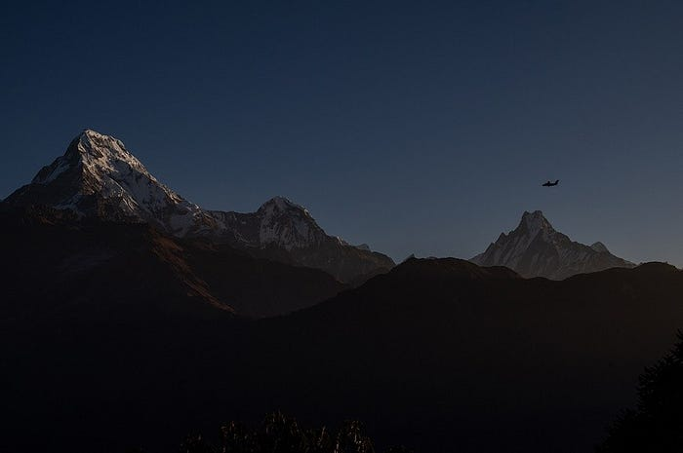
“We had a lot of ice and it was very slippery … we had micro spikes one of those times.” ( [Tripadvisor][3]
In fact, the trail surface is mostly firm and dry during the day, but you may expect slippery sections from frost or melted snow re-freezing at dawn. Therefore, good trekking boots with firm grip, possibly trekking poles and traction attachments are advised. In terms of accessibility, transport from Pokhara 820m via Nayapul is generally unhindered in February. Winter roads tend to be clear, though early morning fog or chill may delay local buses slightly. Accommodation in Ghorepani and nearby villages remains open, though quieter — check ahead.
In conclusion, the February trail is quite doable for prepared trekkers: the route is open, accessible, and less crowded. You must, however, respect the winter conditions: early departures from lodges to reach Poon Hill for sunrise, careful footing on icy patches, and alternate plans in case the snow increases. With this in mind, your Poon Hill trek can feel more like a winter mountain walk into solitude and panoramic clarity rather than a strenuous high-altitude expedition.
Check out the major highlights of Poon Hill Trek: dawn at Poon Hill viewpoint (3,210 m), rhododendron forests, sweeping Annapurna-Dhaulagiri views, and quiet winter trail experience in February.
Highlights of the Trek
Meanwhile, the highlight of the trek lies undeniably in the predawn ascent to the viewpoint at Poon Hill (3,210 m). You leave early in the dark from Ghorepani (2,874 m), reach the ridge, and wait as light slowly bathes the imposing peaks of Annapurna South (7,219 m), Dhaulagiri I (8,167 m), and Machhapuchhre (6,993 m) in golden hues. Standing there in February, you’ll feel crisp air, sparkling frost, and mountains outlined sharply against a clear sky. The moment is timeless. The forest parts of the trail, especially between Ulleri (2,050 m) and Ghorepani, wind through rhododendron, oak, and fir.
Although the blooms peak in spring, the woods in February have a quiet beauty: the bare branches, hints of snow, and frost-touched leaves create a tranquil landscape. The stillness of early winter gives you space to listen, breathe, and absorb.
Besides, the villages of Tikhedhunga, Naya Pul, and Ulleri show traditional Gurung and Magar hospitality, rustic teahouses, and local charms. It is the panorama of the mountain that truly impresses. From viewpoints en route, and from Poon Hill itself, one can see sweeping ridges of the Annapurna range, the curvaceous massif of Dhaulagiri, and valleys carpeted in shadow and light. Winter dryness and clear skies often produce some of the sharpest visibility of the year in February. That clarity equates to stellar shutter-click moments and memories of vast Himalayan space.
In a nutshell, trekking Poon Hill in February is more than a hike; it is an immersive winter mountain experience that combines solitude, sweeping vistas, and wholesome hill-village culture. If you keep to your early-morning schedule, layer up properly, and walk with purpose, you will complete your trek with the clear sunlight on high peaks in winter, the hush of the trail, and a vivid sense of having seen the Himalayas in their quiet, clear, and pure time.
Poon Hill 3,210 m trek through crisp February landscapes of snow-tipped peaks, quiet villages, and clear winter skies that offer unrivaled Himalayan vistas.
February Landscapes and Scenery
And hence, you start your February trek to Poon Hill-3,210 meters amidst a landscape changed by the hush of winter. You walk under pale blue skies, where the air is cold, crisp, and alive with stillness. Snow lingers on ridges and treetops, and the peaks of the Annapurna South-7,219 meters, Dhaulagiri I-8,167 meters, and Machhapuchhre-6,993 meters emerge sharply above the horizon, each ridge and glacial slope carved by winter light.
Because it is off-season, the villages of Ghorepani (2,874 m) and other stops seem quiet, almost meditative. Smoke curls lazily from small lodges, windows frost at dusk, and the daytime climbs glow softly in low winter sunshine. You pass through rhododendron- and fir-clad hillside trails that are dusted with frost, and though the forest is bare of full blooms, it holds an austere beauty: silvery tree trunks, small patches of snow, and the hush of fewer walkers. The sun rises later, and the view from Poon Hill at dawn rewards patience: golden light sweeps first across Dhaulagiri’s western face, then across Annapurna’s ridges, each contour etched in cold air.
Press enter or click to view image in full size
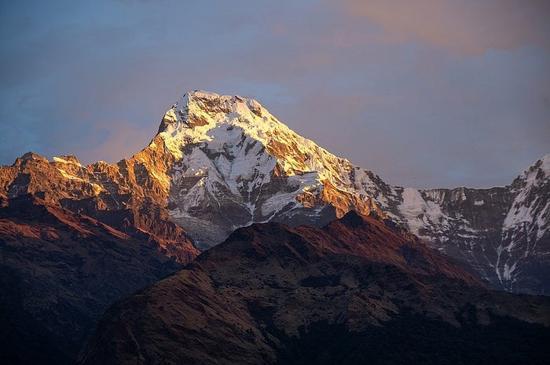
Moreover, the snow-capped peaks stand out vividly against the clear blue backdrop, unblurred by monsoon mist or late afternoon haze. At early morning you may step onto the viewpoint trail in darkness, watching headlamps bob along the ridge, then suddenly the first rays illuminate the Himalayan giants. The chill in the air amplifies the clarity of the scene: every ridge, every snowfield, every thin line of glacier catches light and shadow with startling definition. Below you, the valley stays quiet. Only the occasional crow of a distant rooster or faint bell of a mule breaks the stillness.
Later, as you descend, you cross through mountain villages that appear almost suspended in winter time. Roofs hold thin layers of snow, walls glint with frost, and the path of footprints through the tea houses marks today’s few trekkers. The cold enhances the sense of isolation and clarity: colors are muted, green forests replaced by greys and whites, but the mountain majesty feels more palpable. You may spot the steep stone staircases from Ulleri through bare oak trees, each step edged with frost in the early hours.
Also, the beauty of February lies not only in snow but in contrast: lower hills may remain green or dusted lightly with snow, while high ridges are heavily white, giving the mountains a layered look of winter’s hand. Clouds are fewer, visibility stronger, and the low sun angle casts long shadows across the ridges, making the terrain appear sculpted. You stand at Poon Hill viewpoint and observe innumerable spurs, gullies, and snowfields stretching toward distant peaks.
Assess the difficulty of the Poon Hill trek in February: altitude gains, daily walking hours, tips for stamina specifically in winter, and how to train for cold-weather trekking.
This, in the end, is what it means to hike Poon Hill in February: to walk into a rare clearness and quiet of the Himalayas. With fewer footprints on the trail, cold air that sharpens every outlook, and snow-touched forests that whisper stillness, the scenery becomes more than pretty-it gets immersive. Your lens, your breath, your thoughts-everything aligns with the mountain shapes; you feel part of a winter canvas in which light, rock, and snow converge in harmony.
Level of Difficulty — Physical Fitness
Meanwhile, as you prepare for the trek to Poon Hill (3,210 m), you need to understand that the route, while moderate, has extra physical demands during winter in February. Then you need to also recognize the daily elevation gain and walking time: from the 1,070-metre-high Nayapul, you go up through villages, forest, and ridges to Ghorepani at 2,874 meters and then finally to Poon Hill at 3,210 meters. The climb from Nayapul to Ghorepani takes about 800–1,000 metres of ascent over 4–6 hours; you will need to sustain 4–7 hours of walking every day.
In addition, it contains steep staircases of stone, especially at Ulleri, with sharp uphill grades in some sections. In February you may face cold starts, icy parts, and slower pace because of frost or even patches of snow. One guide from a trekking agency reports that in winter “trekking for long hours during cold days can be difficult, so we suggest taking frequent breaks”.
Moreover, though 3,210 m is not considered to be a particularly extreme altitude, the combination of lesser daylight, winter chill, and possible ice increases the effort required. As one difficulty summary explains: though altitude issues are rare, they are “unusual but real” at this height.
In order to be properly trained for this trek, one should build up stamina and strength weeks in advance: cardio workouts like running or cycling, stair climbing to simulate stone steps, hikes with a loaded backpack, leg strength exercises, and balance drills all help. Especially for February, you should also train in cold-weather gear if possible, walk early in the day to simulate chill mornings, and practice downhill walks to protect knees when descending.
Further, on the trail, keep a reasonable pace, including walking with trekking poles for stability, and keep yourself hydrated; avoid the temptation of pushing hard on icy slopes. Take short breaks, eat high-energy meals, and stay warm in your gear at the end of each day. In so doing, you minimize fatigue and maximize your pleasure.
Altitude and elevation profile of the Poon Hill trek: starting point Nayapul is 1,070 m, Ghorepani is located at 2,874 m and summit viewpoint Poon Hill at 3,210 m. Use table for clarity.
In a nutshell, Poon Hill Trek is at an average trekker’s level, though in February, the cold and winter conditions add to the physical challenge. By training ahead, pacing yourself, dressing appropriately, and respecting early mornings and potential icy patches, you will complete the trek with energy and satisfaction rather than struggle.
Altitude and Elevation Profile
Below is a clear elevation profile for your trek route on the Poon Hill trail. The figures give key points:
From Nayapul (1,070 m), it is about 1,804 m of ascent in total over 2–3 days to Ghorepani at 2,874 m. Then the dawn climb from Ghorepani (2,874 m) to Poon Hill (3,210 m) is about 336 m of uplift.
Furthermore, due to its moderate altitude ceiling of 3,210 meters, risks of high-altitude sickness are generally low but not zero. Some trekkers may experience mild headache or fatigue symptoms, especially in cold winter conditions.
Importantly, the elevation descent after Poon Hill back to Nayapul is a relief for most: once you complete the dawn view and descend into the lower hills, you reduce altitude gradually, and your body relaxes into the final descent.
A realistic 5-day Poon Hill trek (3,210 m) from day-to-day walking hours, overnight stops, and scenic highlights in tune with the peaceful trail in February.
In summary, the elevation profile reflects a manageable climb, especially compared to high-altitude treks. Yet you are still gaining over 2,000 m overall and doing so in winter. So you should pace your ascent, respect your body, and use the elevation chart to guide your planning and gear choices. The above table provides key reference for those major elevations on the classic Poon Hill route.
5- Day Poon Hill Trek Sample Itinerary
Indeed, a five-day Poon Hill trek in February offers the perfect balance of comfort and Himalayan adventure. Because the route remains open and well-maintained even during winter, trekkers can complete it within a short schedule without rushing. Below is a practical, day-to-day itinerary that combines acclimatization, scenic stops, and realistic walking times while enjoying the serene February landscape.
Day 1: Pokhara (820 m) — Nayapul (1,070 m) — Tikhedhunga (1,570 m)
First of all, take an early morning drive from Pokhara to Nayapul, which usually takes two hours. From Nayapul, one starts walking along Modi Khola valley through Birethanti at 1,025 m and terraced fields of Hille. The gentle trail now slowly climbs to Tikhedhunga. Walking time averages four to five hours. Overnight stay at a comfortable teahouse in Tikhedhunga.
Day 2: Tikhedhunga (1,570 m) — Ulleri (2,050 m) — Ghorepani (2,874 m)
The day starts with a steep but steady climb along the 3,200 stone steps leading to Ulleri village. It is better to start a little late as February mornings are usually cold. From there, take the forested trail via Banthanti and Nangethanti to Ghorepani. Arrive in the late afternoon, taking around six or seven hours depending on conditions of snow or frost. Overnight stay will be in a nice lodge looking towards the mountains.
Day 3: Ghorepani (2,874 m) — Poon Hill (3,210 m) — Tadapani (2,630 m)
Consequently, get up early in the morning, before sunrise, for a hike to the view point of Poon Hill. It takes about 45 minutes to an hour to climb it. A beautiful sight is displayed of sunrise over Dhaulagiri 8,167 m, Annapurna I 8,091 m, and Machhapuchhre 6,993 m from the top. After the view, descend to Ghorepani for breakfast and continue the walk toward Tadapani through rhododendron forests. Total walking time averages six hours. Stay overnight at Tadapani with panoramic views of the Annapurna range.
Day 4: Tadapani (2,630 m) — Ghandruk (1,940 m)
Then, begin your downward journey through lush forest trails to Ghandruk, which is a traditional Gurung village. This takes approximately three to four hours. Ghandruk offers museums on culture, warm lodges, and close-up views of Annapurna South (7,219 m). February evenings here are crisp yet peaceful. Nights in village teahouses enjoying the local hospitality.
Day 5: Ghandruk (1,940 m) — Kimche (1,640 m) — Pokhara (820 m)
Or Optional Itinerary from Pokhara to Pokhara:
Finally, trek downhill to reach Kimche in about one to two hours, and from there, take a jeep drive back to Pokhara, reaching there by afternoon. The full cost of such a five-day winter trek, permits included (TIMS and ACAP), guide, and accommodation, ranges between USD 350 to USD 500 depending on the service level.
In the end, this five-day February Poon Hill itinerary offers a full Himalayan experience: peaceful trails, cultural charm, and breathtaking sunrise views. Short but rewarding, it still remains one of Nepal’s best winter trekking adventures for comfort seekers and photography lovers alike.
Day 01: Drive to Ulleri/ Banthanti and trek to Ghorepani ( 6 hrs total)
Day 02: Trek to Tadapani ( 6 hrs)
Find out where to stay during a Poon Hill (3,210 m) trek in February. Learn about teahouses, room warmth, availability of hot showers, and heating options in winter.
Day 03: Trek to Ghandruk Village (2 hrs) ( Overnight stay or drive back to Pokhara after lunch)
Winter Accommodation and Lodges
While doing the Poon Hill Trek in February, accommodations are available and affordable, although there are fewer lodges open than during the high seasons. Almost every village, including Tikhedhunga (1,570 m), Ghorepani (2,874 m), Tadapani (2,630 m), and Ghandruk (1,940 m), has year-round teahouses. These are mostly family-run lodges offering simple but warm rooms, delicious food, and friendly hospitality. In February, you will more often find quieter lodges and more personal service.
Apart from that, the rooms are shared, mostly with twin wooden beds with foam mattresses, blankets, and pillows. Since winter nights sometimes get below freezing, especially in Ghorepani or Tadapani, it’s a good idea to bring a -10 °C sleeping bag. Most of the rooms are clean and simple, with insulation being variable and sharing bathroom facilities. Although few foreigners trek here during the winter months, many local trekkers keep the lodges open, along with villagers who maintain them.
In addition, most lodges have a main dining room with a wood or kerosene stove for heating. Trekkers tend to congregate there every evening for hot meals and conversation. However, bedroom heating seldom occurs, and heated rooms might be confined to dining rooms where everyone can congregate. Hot showers are offered by most of the lodges for a minimal surcharge and can be provided by solar or gas. Water has been known to freeze in pipes overnight during February, so it is usually not advisable to take an early morning shower.
Importantly, since February is off-season, there is no need to book rooms in advance; accommodation can easily be found upon arrival. However, it is essential to bring cash in Nepali rupees with you, as ATMs are not available beyond Nayapul (1,070 m). Food and lodging thus cost about NPR 2,000–3,000 per day, depending on choices. Lodges can normally serve dinner, breakfast, and tea in-house, keeping trekkers comfortable even in cold weather.
The power supply is provided via solar panels or small hydro generators. It’s possible to charge your phones, cameras, and other devices for NPR 100–200 per device. Wi-Fi can be accessed in Ghorepani and Ghandruk at some teahouses, although the strength can be pretty weak on cloudy days. Despite such simplicity, winter accommodations feel warmer through community spirit wherein hosts share stories and often light extra fires when the frost thickens outside.
Learn what to eat and drink on the Poon Hill trek in February, from hot soups to Nepali dal bhat, teas, vegetarian meals, and hydration tips for cold-weather trekking.
To sum up, the accommodations along the Poon Hill trek in February can offer comfort, warmth, and safety even in cold conditions. Provided you have the right sleeping gear, can enjoy warm tea by the fire in the dining space, and you respect the local rhythm of life, then this winter lodging experience will be wholly authentic and memorable.
Food and Drinks on the Trail
Similarly important, food and drinks along the February Poon Hill trail also play their role in maintaining energy and heat. Every stop-from Nayapul at 1,070 meters to Ghorepani at 2,874 meters and then Tadapani at 2,630 meters-offers fresh, homemade food that warms up the body and soul. The menu throughout this route is similar; it focuses on warm, hearty, and simple Himalayan food. Breakfast usually consists of porridge, chapati, omelette, pancakes, or Tibetan bread with honey or jam. On chilling mornings in February, hot ginger tea or masala milk tea refreshes you just in time.
For lunchtime, noodles, fried rice, momos, and vegetable soup are available upon order by trekkers. With the fall of temperatures, soups like garlic, lentil, and vegetable become favorites due to both warmth and altitude protection. Dal Bhat is a typical Nepali dinner, with rice, lentil soup, vegetables, and pickles. It’s unlimited, nutritious, and perfect for replenishing after big climbs. Vegetarian and vegan trekkers find ample options, including fried potatoes, spinach curry, egg dishes, and pasta with local vegetables. Meat is available but not recommended above Tikhedhunga due to transport difficulties in cold weather.
And, as in winter, hydration is also paramount. You must drink three to four litres of fluid every day. Trekkers fill bottles up with boiled water or purchase sealed mineral water at higher points for NPR 100–150 per litre. Most lodges also offer thermoses of hot water for a small fee, which helps prevent dehydration and keeps you warm at night. Avoid cold soft drinks in winter as they will lower your body temperature.
Then again, these February nights call for social moments around the dining stove, where trekkers would take hot lemon, ginger honey tea, or cocoa while sharing tales. Drinks containing alcohol, such as local raksi, are also available but must be taken in moderation because they dehydrate quickly in the cold. Caffeine, too, should be limited to ensure good rest. Food and drinks on the Poon Hill trek in February are both comforting and sustaining.
Prepare your packing list for the February trek to Poon Hill (3,210 m): thermal layers, insulated jackets, micro-spikes, gloves, and winter gear to keep you warm and safe on snow-touched trails.
Actually, with every hot soup, steaming plate of dal bhat, and shared cup of tea, you regain warmth and strength for the next day’s walk. Balanced nutrition, safe hydration, and mindful eating make your winter trek healthy and memorable.
Essentials to Pack for February Trek
Meanwhile, pack smart for a February trek to Poon Hill at 3,210 meters because winter conditions call for added preparation. Your base layers matter a great deal: wear a long-sleeve thermal top moisture-wicking and bottoms as your first layer, with the addition of a mid-layer fleece or a lightweight down jacket for added warmth. Bring along an insulated jacket-preferably down or synthetic-rated to -15 °C-and a windproof outer shell to block chilly gusts during those early morning climbs and on ridge walks. A pair of gloves is necessary: a lightweight liner glove and a warm over-glove or mittens; consider a waterproof shell glove for wet or snowy conditions.
Besides, one needs to pay special attention to foot gear. Your trekking boots must be waterproof and well-broken in with good ankle support, as the trail may carry icy patches between Ghorepani (2,874 m) and Poon Hill. Add a pair of micro-spikes or crampon attachments for early-morning frost or light snow sections; these may save you from slips on stairs and ridges. Bring warm, moisture-wicking trekking socks, two or three pairs, and a pair of camp shoes or sandals for evenings in teahouses.
Furthermore, your backpack and sleeping gear matter almost as much as the clothes themselves. Choose a day-pack of about 25–30 litres for trekking days and a larger 40–50 litre pack for transit days. Include a -10 °C rated sleeping bag to cover winter nights, especially at Ghorepani or Tadapani where temperatures drop below freezing. A good sleep sheet liner adds hygiene and warmth. Pack a headlamp (with extra batteries), trekking poles (helpful on slippery stone staircases), and a water bottle with an insulated flask to keep hot drinks hot.
And don’t forget accessories and personal things: a warm hat, buff or neck gaiter, UV sunglasses because the snow glare can be extremely intensive, sunscreen for sunny winter days, and lip balm. Take a simple first-aid kit with blister plasters, painkillers, altitude sickness medicine, and personal medications. A power bank for camera/phone charging, plug adapters, and a small dry bag for electronics are quite handy, too.
Also bring an extra set of dry clothes for evenings, a lightweight down jacket for lodge use and a waterproof dry-bag for packing away wet or snowy items. For hygiene use hand-sanitiser, toilet roll and wet wipes as lodge amenities may be limited in winter. A travel towel and earplugs may improve your sleep in common dorm rooms.
Learn about the permits required for the Poon Hill 3,210 m trek in the Annapurna Conservation Area region: ACAP permit and TIMS card, current prices, and where to get them in Nepal.
Finally, pack thoughtfully and travel light, aiming for 10–12 kg excluding a sleeping bag if possible, because even moderate treks feel harder when you carry excess weight. Always check the weather forecast before leaving and add or remove layers or accessories as appropriate. With this full winter trekking checklist, you will be ready for February’s crisp trails, clear skies, and snow-touched Himalayan environment around Poon Hill. The right gear provides you with confidence, comfort, and allows you to pay attention to the mountain views and not to the cold.
Permits Required for the Trek
Meanwhile, before you step onto the trail to Poon Hill (3,210 m), you have got to secure the proper permits for legality and safety. The key documents you need are the Annapurna Conservation Area Project (ACAP) permit and the Trekkers’ Information Management System (TIMS) card. An ACAP permit covers entry into the Annapurna Conservation Area, while the TIMS card records your trekking registration for safety. For foreign nationals, the ACAP fee is approximately NPR 3,000 (~USD 25). Independent foreign trekkers have to pay about NPR 2,000 (~USD 17) for a TIMS card. There are reduced fees that apply to SAARC nationals; for example, ACAP ~NPR 1,000 and TIMS ~NPR 1,000.
Press enter or click to view image in full size
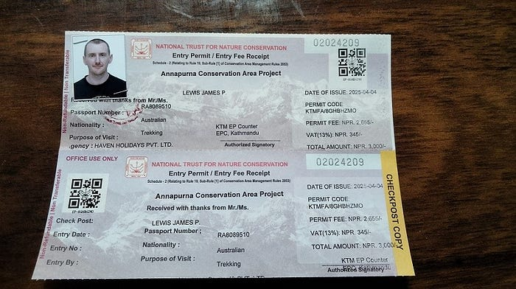
Here, you can obtain these permits in Kathmandu or Pokhara. To be precise: the offices of the NTB in Kathmandu (Bhrikutimandap) and in Pokhara (Lakeside area) issue them. Some trekking agencies handle the paperwork for you and may include the cost in the package.
Once issued, carry both documents with you as checkpoints appear early on the trail, such as at the Nayapul (1,070 m) entry point. Missing documents can incur fines or delay. Keep copies and a digital photo as backup; lodges may check them along the trek.
Learn how to get from Pokhara (820 m) to the trailhead at Nayapul (1,070 m) for the Poon Hill trek, via bus or jeep, with travel time, typical cost and tips for February departures.
Note, rules evolve: for years the TIMS card was mandatory, but more recent sources reflect policy revisions for some routes. It is wise to confirm the current requirement with your trekking operator.
Summary: Budget around USD 40–45 for these permits (foreigners), and allot 30–60 minutes in Pokhara or Kathmandu for processing. To expedite the process, bring a passport copy, photos (two passport-size), and a trekking itinerary with you. In this way, with permits, you will be able to trek legally, support conservation, and allow mountain rescue mechanisms-important for any winter trek to Poon Hill.
Getting to the Trailhead from Pokhara
Meanwhile, your journey to Poon Hill at 3,210 meters starts with a drive from Pokhara at 820 meters to the main trailhead at Nayapul, 1,070 meters. It is approximately 41–58 km via rural roads through Sarangkot and Lumle, taking about 1.5 to 2 hours in a private vehicle.
For budget travelers, a public bus is also available from Pokhara to Nayapul. However, the bus may take 3–4 hours because of stops, transfers, and road conditions. Typical fare for a bus or shared jeep is about NPR 500–700 per person. In a shared jeep, the cost may rise to NPR 1,000 or more. Private jeep hire from Pokhara to Nayapul costs about USD 30–45 (~NPR 4,000–6,000) for up to three passengers.
For February, it is much recommended you schedule travel to arrive in Pokhara the day before the tour starts. Depart early in the morning, preferable in the early morning before 9 am, for daylight driving and on-time arrival at Nayapul. The winter season road conditions are pretty good; however, you should confirm if any recent snowfall or fog might slow down your progress.
Hiring a local guide or porter for the Poon Hill trek in February will not only add to the safety of the icy trails, but also provide deep insight into the culture.
Likewise, your driver will pass through scenic villages and terraced hillsides; despite the short route, the views are rewarding and set the tone for your trek. Once at Nayapul, trekking begins along the Modi Khola valley, and you’ll pass through Birethanti before continuing to Tikhedhunga or Ulleri. Make sure you bring your luggage and trekking gear to Nayapul and that your driver lets you off at the official trailhead, where there is a sign saying ‘Poon Hill route’.
Most importantly, check that your trekking permits (ACAP and TIMS) are in order to present at the checkpoint in Nayapul. In the end, the transfer from Pokhara to Nayapul is easy, affordable, and sets you up for the trek ahead. Whether by bus or by jeep, try to arrive early, check the road status in advance, have some small denomination Nepalese rupees with you, and you are all set to start your February Poon Hill adventure.
Hiring a Guide or Porter in February
Meanwhile, a guide or a porter for the Poon Hill trek at an elevation of 3,210 meters in February ensures safety and comfort on cold and at times icy trails. As February brings snow and slippery stone steps near Ghorepani at 2,874 meters, local guides are at your service to guide you through these conditions safely. They know alternative routes, set your pace, and keep tabs on weather forecasts. Their expertise will reduce the risks of falls or frost-related problems solo trekkers may face in early mornings.
Moreover, licensed guides also provide other services beyond navigation. The guides will provide important information about the local history, stories, and customs of villages such as Gurung and Magar villages along the way. They assist in communicating with lodge owners to plan accommodations even during seasonal closure. A USD 25–30 per day certified guide registered under the Trekking Agencies Association of Nepal (TAAN) normally covers meals and insurance. Hiring through a registered agency ensures professionalism and legal trekking permits.
Besides, porters play a significant role, especially in winter, when the heavy clothes and gear increase your backpack weight substantially. A porter carries up to 20–25 kg so that you may trek comfortably and save energy for steep ascents. Porter wages usually vary from USD 20–25 per day, and it will not be a bad idea to insure them through your agency. During February, the porters also contribute to testing the icy paths ahead and to fast assistance when trails are covered with snow or hidden stones.
Compare solo and group trekking for the Poon Hill trek in February, balancing freedom, safety, and winter trail challenges for all trekking styles.
In fact, local hiring helps the economy of Annapurna Conservation Area and creates livelihoods in months when the flow of tourists is slower. You will also get true hospitality from locals who are proud of their homeland. Guides often help explain mountain names like Annapurna South (7,219 m) and Dhaulagiri I (8,167 m) seen from Poon Hill, turning your trek into an educational journey. They can also handle altitude or health concerns, arrange rescue contact, or liaise with nearby medical posts if needed.
Finally, trekking with a professional guide or porter builds safety, connection, and peace of mind. In February’s cold mornings and snowy descents, having experienced companions makes the journey more enjoyable and secure. For your trek to Poon Hill, the modest cost is a small price for safety, support, and rich cultural storytelling.
Solo Trekking vs Group Trekking
First of all, February invites both solo trekkers who are looking for solitude and groups that crave shared adventure on the Poon Hill trek at 3,210 meters. The freedom of solo trekking gives you independence: you determine your schedule, pace, and rest stops. You can spend time at viewpoints, taking pictures of sunrises or having conversations with villagers at your own pace. However, the conditions of February also build up some unique challenges: snow or ice blocking stairs, fog reducing visibility, and fewer trekkers mean less help around. Therefore, solo trekkers must prepare well and be alert in such conditions.
Press enter or click to view image in full size
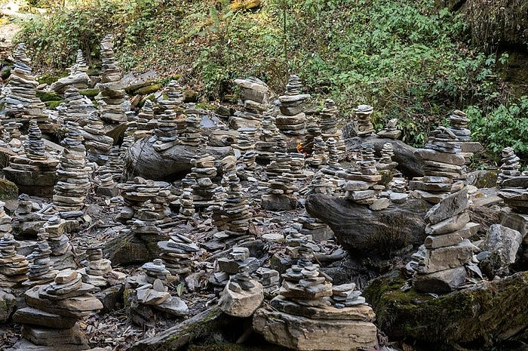
On the other hand, group trekking offers safety, companionship, and logistical comfort during winter. Traveling with two or more people helps manage the risks associated with the icy sections near Deurali or Tadapani, at 2,630 meters above sea level. Groups can split up the costs for guides, porters, or private jeeps and can carry shared safety gear like microspikes, ropes, and first-aid kits. In February’s shorter daylight hours, having company also offers psychological motivation and warmth in shared lodges. Many trekkers who travel in groups form lasting friendships over dinner and storytelling around a wood stove.
Stay safe on the Poon Hill trek in February because of winter safety tips: frostbite prevention, icy trail handling, and emergency contacts for trekkers.
Furthermore, with a local agency, group trekking involves guides licensed to control permits, weather updates, and lodge reservations. Organized groups move systematically for better acclimatization and reduced fatigue. On the other hand, solo trekkers must handle all planning details-permits, route checks, and safety decisions-independently. As much as solitude may appeal to many, it can pose a problem during winter months when some trails grow quieter.
Additionally, in February, the temperature drops below freezing in Ghorepani (2,874 m), and solo trekkers may find it much more difficult to locate open lodges without advance coordination. Groups have an easy time getting rooms through guide networks. Communication is another advantage: in cases of emergencies or navigation errors, a group’s support prevents risks.
Basically, both the options are valuable. Solo trekking allows flexibility and solitude for experienced trekkers acclimatized to cold weather, while group trekking keeps safety, warmth, and structured support in focus. If you are a first-timer in winter, then a small guided group will be ideal. Confident trekkers, though, who have winter gear and prior Himalayan experience, can safely savor the serene February landscapes alone. It depends on your skill, comfort with risk, and love for solitude or companionship.
Safety and Winter Precautions
Basically, February in the Annapurna region requires extra attention to safety. Early mornings near Poon Hill (3,210 m) can reach temperatures below -5 °C, and frost may cover stone stairs between Ulleri (1,960 m) and Ghorepani (2,874 m). Therefore, wearing proper layers and using microspikes on the slippery paths are quite important to avoid falls. Always trek slowly on icy descents, using trekking poles for balance.
Find peace in the Poon Hill trek in February. Fewer trekkers, quiet lodges, and tranquil trails make it a personal connect with the Himalayas.
Further, the prevention of frostbite needs to be considered. Fingers, toes, and ears need to be kept covered with insulated gloves, socks, and caps. Avoid tight shoes that restrict circulation. During long photo stops at Poon Hill sunrise, keep moving or flex fingers regularly. Stay hydrated well to maintain warmth and stamina, even in cold weather. If your skin becomes numb or pale, rewarm it slowly with gentle movement and never with direct heat. Furthermore, be aware of altitude sickness signs even though Poon Hill is at a moderate altitude. Drink plenty of water, rest properly, and avoid alcohol at high altitude lodges. Carry basic medicine like Diamox and keep an emergency kit for mild headaches or nausea. Always share your itinerary with your guide or lodge owner so others can locate you in case of delay.
Additionally, in February, the weather can change within a very short period. Check the forecast daily through lodges or local guides. Avoid heavy snowfall or foggy hikes and try to reach your destination before 4 pm. Carry emergency numbers with you: Nepal Tourism Board +977 1 4256909 and TAAN Rescue +977 1 4440920. Keep your phone charged by carrying a power bank, and store vital contacts on paper as batteries fail in cold conditions.
And lastly, let mountain safety principles be heeded at all times: never trek off marked trails, never overexert yourself, and stay alert for hypothermia signs such as uncontrollable shivering or confusion. These couple of winter precautions will make your Poon Hill trek in February not only scenic but also safe and unforgettable, hence letting you enjoy the snow-covered Himalayas full of confidence.
Crowd Levels and Trekking Experience
Press enter or click to view image in full size
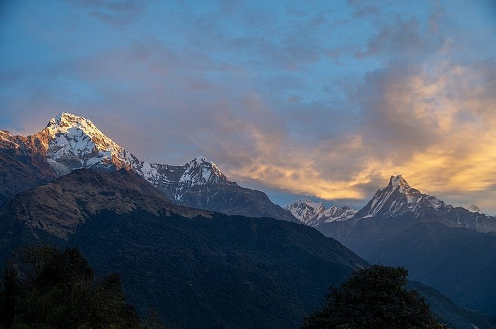
Meanwhile, February makes Poon Hill trek (3,210 m) a quiet and contemplative walk through the Annapurna region. Very different from the busy trails in spring and autumn, February brings calm pathways, noiseless forests, and tranquil villages in the area. The freezing air and minor snow contribute to a meditative trekking environment whereby you encounter no more than a few other travelers each day. Hence, you can behold uninterrupted mountain views, empty viewpoints, and a closer connection to the Himalayan wilderness.
Capture the magic of winter photography during the Poon Hill trek in February: perfect sunrise light, contrasting snow glow, and expert camera tips for the Himalayas.
Additionally, fewer trekkers mean more freedom in planning your days: you can start late in the morning when sunlight warms the trails or take your time at scenic stops without the crowds. Teahouses in Ghorepani (2,874 m) and Tadapani (2,630 m) are very welcoming during this quiet season and may well offer you the best rooms complete with wood-burning stoves. The owners of lodges have more time to talk to you, share stories, and serve extra tea by the fire. This personalized hospitality adds to the warmth and authenticity of the experience, making February an ideal month for cultural immersion.
Besides, this tranquility increases your interaction with nature. Passing through the rhododendron forests near Banthanti (2,210 m) or up to Deurali (2,960 m), you might hear only the crunch of snow under your feet and some birds chirping somewhere. Each sunrise and sunset feels more personal without any noisy groups. You can meditate at Poon Hill while golden rays strike Dhaulagiri (8,167 m) and Annapurna South (7,219 m) without the usual crowd of cameras. This rewards both photographers and peace seekers.
Adding to that, the low number of tourists in February simplifies logistics: rarely will you have to book rooms in advance, lodges are cheaper, and sometimes offer discounts for early arrivals. It is also easier to get porters and guides, who may be more flexible with itinerary changes. On clear days, crisp winter air provides excellent visibility, offering unbroken panoramas of the Himalayas from dawn to dusk.
Press enter or click to view image in full size
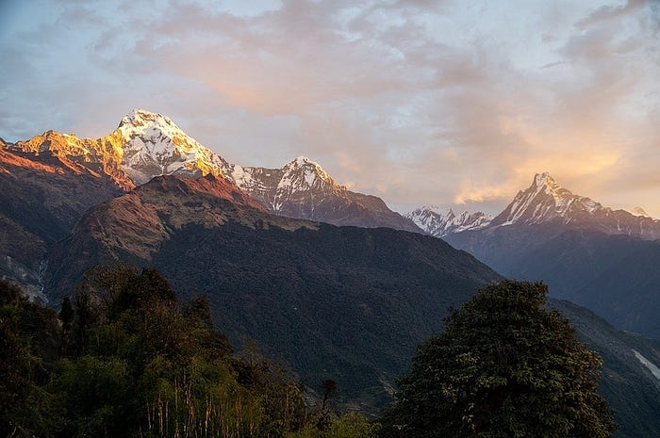
Ultimately, the trekking in February offers a rare blend of silence, personal space, and genuine local warmth. At times, temperatures test comfort, but serenity pays tenfold. It is this off-season calmness that will make the Poon Hill trek not merely scenic but deeply personal: an experience of solitude, reflection, and true stillness of the Himalayas.
Photography and Sunrise Moments
Experience Gurung and Magar Village life in the Poon Hill trek in February-warm fires, winter routines, and heartfelt Himalayan hospitality.
Meanwhile, February rewards photographers with crystal-clear skies and snow-draped peaks that glow under soft winter light. Poon Hill (3,210 m) is famous for sunrise views over Annapurna I (8,091 m), Dhaulagiri (8,167 m), and Machhapuchhre (6,993 m). The best shooting time is from 6:15 a.m. to 7:00 a.m., when the horizon turns orange and peaks shimmer in gold. Arrive early-about 30 minutes before dawn-to secure your tripod spot and adjust camera settings before the sun breaks.
Additionally, the snow in February increases contrast, making the images brighter with sharper mountain definition. A polarizing filter reduces glare and deepens blue skies. A wide-angle lens (16–35 mm) captures the entire panorama of the Himalayas, while a telephoto lens (70–200 mm) frames peaks like Nilgiri (7,061 m) or Annapurna South (7,219 m). Keep spare batteries next to your body since cold quickly drains batteries.
Likewise, the trail itself offers wonderful shots around mid-day and evening. Villages, such as Ghorepani at 2,874 meters and Ulleri at 1,960 meters, with their traditional stone houses and snow-lined roofs, are ideal for cultural frames. Afternoon light at around 3 p.m. gives way to long shadows fallen across the terraced fields, thereby underlining the depth in Himalayan valleys. Cloud layers make interesting backdrops for creative photography.
Here, remember to balance composition and exposure in the snowy landscape. Slightly underexpose-0.3 EV-to prevent over-bright snow. Add a subject-trekkers, flags, or trees-for perspective. During the blue hour after sunset, keep your ISO low (100–400), and shoot with a tripod for sharp detail. The cameras of even smartphones show amazing results when you have steady hands and HDR settings on.
Festivals in February on the Poon Hill trek include Maghe Sankranti and local Gurung and Magar winter festivals in the Annapurna region.
Lastly, February’s silence enhances the emotional bond between the photographer and the mountains. Each photo is personal and does not get touched by many people. You merge patience with perfect timing and settings, which caught not only the sunrise but also the essence of the Himalayas: solemn, pure, and always awe-inspiring.
Local Culture and Village Life in February
Most significantly, February trekking unravels the quieter yet warmer side of local culture along the Poon Hill route. In winter, villages like Ulleri (1,960 m), Ghorepani (2,874 m), and Ghandruk (1,940 m) slow down: family, farming, and festival traditions become the main concerns. Locals huddle under wood stoves, weaving baskets, repairing roofs, or preparing homemade pickles for spring. The air smells of burning pine and lentil stew, welcoming travelers to the village.
Additionally, the season brings out genuine hospitality. Since fewer trekkers are coming, they have time to relate stories, folklore, and customs. Many of them belong to the Magar and Gurung communities-both of whom are known for bravery and kindness. Over steaming cups of milk tea or raksi, they relate stories about ancestors who served in Gurkha regiments or climbed the local peaks. These conversations add depth to the trek beyond scenery alone.
Besides, food culture thrives even in winter. You will be treated to dal bhat, vegetable curry, or thick soups made with potatoes, garlic, and local greens. Many trekkers join families for dinner, learning to cook over open fires. Teahouses also offer thicker bread, honey pancakes, and more ginger tea during February to keep guests warm. Besides, the community life goes on, including in cold weather: children go to school in Ghandruk (1,940 m), elders weave wool, and women come together in the evenings to sing traditional songs. Local lodges use this quiet time to maintain trails or improve rooms in preparation for the spring rush. Some festivals, such as Sonam Lhosar, occasionally fall in February and bring music, dances, and Buddhist rituals to nearby villages. Finally, February invites you to experience the Himalayas as locals live them-peacefully, resiliently, and with open hearts. Beyond the snowy paths and mountain views, there is much warmth inside stone homes, shared laughter over tea, and the gentle rhythm of Himalayan village life that time has not changed.
Festivals and Local Events
Discuss the flora and fauna to be encountered on a Poon Hill trek in February, from dormant rhododendron forests to wildlife viewing in the Annapurnas.
Meanwhile, February offers a different perspective for trekkers on the Poon Hill route: a view of cultural events in full swing at an elevation of 3,210 meters. While most trekking seasons offer mountain views, winter reveals traditional festivals and village rituals. The most prominent is Maghe Sankranti celebrated by the Gurung and Magar communities. It falls on the winter solstice, wherein people thank the sun god for having longer days ahead. Preparation of traditional foods, gathering around fires, and simple rituals are some of the things trekkers get to see regarding Himalayan spirituality.
Besides, Maghe Sankranti falls in mid-January or early February, depending on the lunar calendar. Locals eat walnuts, sesame seeds, molasses, and yam-based dishes for warmth and health during cold months. Villages such as Ghandruk (1,940 m) and Ulleri (1,960 m) hold small community-level events including drum music, folk dances, and prayer ceremonies. That way, trekkers can experience intimate winter celebrations that they can’t have during peak seasons.
Besides this, a number of other smaller local events also take place during February. Farmers finish off their post-harvest tasks, mend roofs, and prepare for spring planting. These routines are complemented by evening gatherings in teahouses, where locals sing traditional songs or play flutes. Trekkers often find opportunities to join in informal celebrations or sample homemade delicacies like buckwheat pancakes and millet bread, adding authenticity to the trekking experience.
Press enter or click to view image in full size
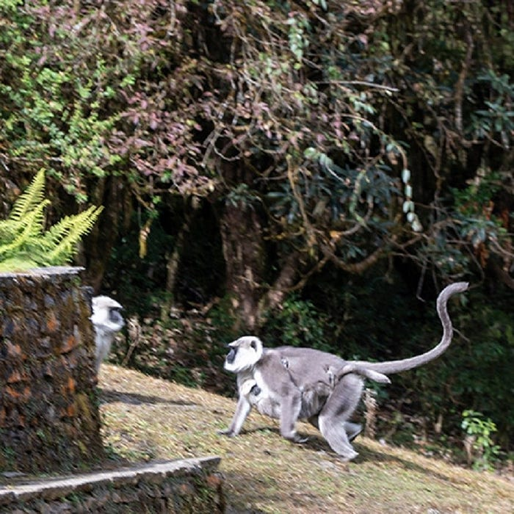
Moreover, February’s tranquil trails grant an opportunity for better cultural digestion. Unlike busy spring trails, you can have more time to watch the everyday life of villagers. Thus, interactions in Ghorepani (2,874 m) or Tadapani (2,630 m) become more personal, with a chance to ask about family, festivals, and local legends. Guides often explain what those prayer flags, stone chortens, and mani walls lining the trail really mean.
Last but not least, festivals and events in February will add depth to the Poon Hill trek. Beyond just snow-capped peaks and sunrises, you witness the resilient winter lifestyles, seasonal rituals, and traditional Himalayan hospitality. You will get indelible memories of culture mixed with nature by planning your trek to coincide with events like Maghe Sankranti or local celebrations.
Flora and Fauna Along the Trail
Indeed, February has a substantial effect on flora and fauna during the trek to Poon Hill at 3,210 meters above sea level. The rhododendron forests in Ghorepani (2,874 m) and Tadapani (2,630 m) are pretty much in their dormant state. Bare branches reveal stone staircases with mountain backdrops and unhindered views of Annapurna South (7,219 m) and Dhaulagiri I (8,167 m). The stark beauty of trees in winter enhances photo opportunities and offers a different perspective than the spring blooms.
Additionally, winter conditions are not very conducive to viewing wildlife. During the cold months, most mammals-like Himalayan langurs, barking deer, and Himalayan tahr-reduce their activity. Birds like pheasants, Himalayan monals, and small passerines remain visible but are less active than during the warmer months. For trekkers, there is the possibility of seeing tracks in the snow or hearing calls from afar, making winter trekking somewhat a discovery.
In addition, low temperatures impact the plant life along the trail. The ground cover slows down growth and the alpine grasses and mosses go dormant. Yet, evergreen species dominated by pine, juniper, and fir add rich green contrast against the white mantle of snow-covered slopes. The mossy banks along the rivers and streams remain vibrant and provide microhabitats for insects and amphibians that survive beneath the winter frost.
Moreover, February’s clear skies improve mountain visibility and emphasize natural landscapes. Stone terraced fields around Tikhedhunga (1,570 m) and Ulleri (1,960 m) display golden-brown hues, highlighting the interaction of humans with nature. The dormant yet scenic landscapes allow trekkers to appreciate Himalayan ecology from a seasonal point of view.
Last but not least, knowledge about flora and fauna in February enriches the experience of trekking: despite an absence of flowers, leafless forests, animal tracks, and contrasts of evergreens do offer many learning opportunities. If you patiently observe, you are able to see how even in the coldest months, the Annapurna region sustains biodiversity-a mix between natural wonder and winter serenity.
Power, Connectivity, and Charging Tips
Keep connected on the Poon Hill trek in February with Wi-Fi, solar charging, and battery management.
Most, importantly, power and connectivity are limited but manageable during a February Poon Hill trek at 3,210 meters. Most of the lodges along the route, from Tikhedhunga 1,570 meters to Ghorepani 2,874 meters and Tadapani 2,630 meters, are with solar-powered electricity. Charging in winter costs NPR 100–200 per item since sunlight hours are lower and the demand is high. This means it is prudent to plan charging sessions during midday for optimal power.
Actually, Wi-Fi is spotty. Ghorepani and Ghandruk (1,940 m) have weak, intermittent Wi-Fi, while smaller lodges have absolutely none. Download the offline maps, trekking itinerary, and emergency contact lists before arriving. Additional helpful tools will be satellite apps and buying a local SIM card that can hopefully have data coverage in Pokhara and Nayapul (1,070 m) for instances of emergencies.
Besides, low temperatures significantly reduce battery life. Store phones, cameras, and power banks in insulated jackets close to your body. It is not advisable to leave electronics in a backpack overnight. Rotate between devices and store fully charged spares for summit or sunrise shots at Poon Hill. Further, solar chargers and power banks become essential on multi-day treks. A 20,000 mAh power bank would last for 3–4 days for phones and cameras if used conservatively. Combine solar chargers with power banks for maximum energy supplies, especially when the sun is bright at midday. Label all devices to avoid mix-ups at lodges with shared charging points.
Finally, managing power, connectivity, and devices means keeping the trekkers safe and comfortable. By combining solar sources with warm storage and strategic recharging, trekkers stay in contact, capture memories, and have a line to emergency services. February means a cold environment, but with preparation, technology can support a smooth and secure Poon Hill trekking experience.
Budget and Cost Breakdown
This article outlines a well-structured February Poon Hill trek budget, inclusive of permit costs, food, lodging, transport, and guide costs in NPR and USD.
Understand the cost, and the trek to Poon Hill at 3,210 meters in February will go smoothly. Winter period treks are somewhat cheaper than in the peak seasons. However, it requires preparation. The major expenses include permits, accommodation, meals, transport, and optionally a guide or porter services. Careful budgeting would avoid surprises at a place like Ghorepani, which is 2,874 meters, or Tadapani, at 2,630 meters.
Permits and Fees: You need to get the Annapurna Conservation Area Permit (ACAP) and a TIMS card. Foreigners pay about NPR 3,000 (~USD 25) for ACAP, while TIMS charges NPR 2,000 (~USD 17) in addition. For SAARC nationals, it costs around NPR 1,000 (~USD 8.5) each. Permissions are available in Pokhara or Kathmandu; some agencies operating in this region may have already included the fees in the price of their package.
Discover why February is ideal for trekking in Poon Hill: clear skies, snow-filled peaks, quiet trails, and an unrehearsed taste of the Himalayas.
Accommodation Costs: Teahouses are open even in February, and though options are limited in smaller villages, one can get a standard room for nightly prices of NPR 400–800 (~USD 3–7) per person, inclusive of basic heating. The costs for dorms are lower while private rooms in Ghandruk (1,940 m) or Ghorepani (2,874 m) may be as high as NPR 1,000–1,200 (~USD 8–10). Add a little more for hot showers, normally costing NPR 100–150 (~USD 1–1.5) per use.
Food and Drinks: Meals include dal bhat, noodles, soups, and tea. The average daily cost will be NPR 700–1,200 (~USD 6–10). For breakfast, options of porridge or bread cost about NPR 150–250 (~USD 1–2). For hot drinks, tea or coffee is available at NPR 50–100 (~USD 0.5–1). Vegetarian options are easily available, and hot food helps to keep the body warm in February weather conditions.
Guide and Porter Services: A certified guide costs about USD 25–30 per day, covering all meals and insurance. Porters will carry up to 20–25 kg for about USD 20–25 per day. Agencies may combine both services into a package deal, thus providing convenience and safety.
Transportation: A jeep ride from Pokhara (820 m) to Nayapul (1,070 m) costs approximately USD 30–45 (~NPR 4,000–6,000), while public buses cost about NPR 500–700 (~USD 4–6) per person. The round trip gets added to the entire expenditure but is very reasonable, though.
Press enter or click to view image in full size
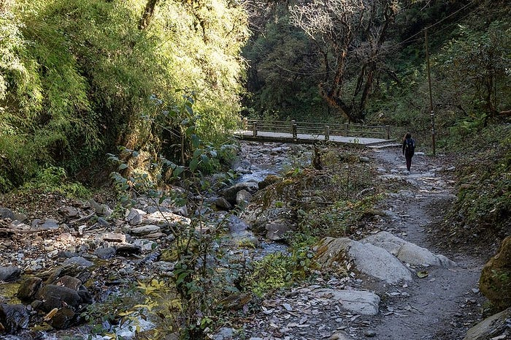
Estimated Total Cost: For a 5-day trek including permits, accommodation, food, transport, and guide, expect NPR 25,000–35,000 (~USD 200–280) per person. Budget can be lower for solo trekkers avoiding guides or higher if hiring private transport and porter support. February offers cost efficiency while providing a unique winter trekking experience.
Poon Hill trek in February is an embodiment of magic: tranquil snow, golden sunrise, and peaceful Himalayan mountain experiences.
Finally, careful planning of every expense makes an off-season journey comfortable, safe, and memorable. Proper allocation allows one to focus on the scenic sunrises, snow-touched trails, and serenity of the Himalayas, rather than day-to-day budgeting.
Benefits of Trekking in February
First, in February, the Poon Hill trek (3,210 m) is much quieter than during spring and autumn. The trails are less crowded, allowing for a more personal time with nature. Fewer trekkers mean lodges in Ghorepani (2,874 m) and Tadapani (2,630 m) are quiet, warm, and welcoming, offering travelers personal attention from their hosts. Quiet trails biodiversity amplifies the sense of adventure and being plunged deep within the Annapurna region.
Additionally, in February, clear skies offer excellent visibility for panoramic mountain views. Fresh powder coats the peaks of Annapurna South (7,219 m), Dhaulagiri I (8,167 m), and Machhapuchhre (6,993 m), where snowfall provides breathtaking photographic opportunities. Sunrise at Poon Hill is particularly magical; the golden light reflects on the snow-capped peaks as crisp air provides increased visibility. The clarity in the off-season offers stunning and unbroken views for trekkers and photographers.
Moreover, winter foliage conditions contribute to unique scenery: although rhododendrons are dormant, evergreen forests and terraced fields form natural contrasts in snow. Wildlife activity is subtle, allowing trekkers to observe animal tracks, bird calls, and quiet natural patterns without disturbance. The trails feel serene and almost untouched, adding a sense of exploration.
In addition, February allows for more cultural exposure. Village life in Ulleri (1,960 m) and Ghandruk (1,940 m) is slow, hence easier to interact with local people. Furthermore, traditional food items, warm drinks, and lodge storytelling add to the beauty of trekking. There are fewer crowds; guides and hosts tend to sometimes share more about insights, history, and local traditions.
Finally, trekking in February balances challenge, comfort, and uniqueness. While cold temperatures call for preparation, reduced crowds, clear skies, snow-covered peaks, and cultural immersion together make it an unforgettable experience. Off-season trekking offers both natural beauty and a sense of peace unavailable during peak months.
Conclusion: The winter magic of Poon Hill
Mainly, Poon Hill at 3,210 m in February offers a trekking experience very unlike any other season. The mountains gleam with snow, the air is crisp, and trails are silent. Unlike busy spring months, February provides solitude, allowing travelers to absorb the serene beauty of the Annapurna range fully. The quiet enhances reflection, creating a sort of meditative connection with the Himalayas.
Additionally, the sunrise over Poon Hill is unforgettable. Early risers are graced with golden light upon Annapurna South (7,219 m), Dhaulagiri I (8,167 m), and Machhapuchhre (6,993 m). The snow blushes pink and orange, while the valleys below sleep undisturbed, framing picture-postcard scenery. Beholding this magical moment encircled by silence stirs a depth of emotion-like feelings of wonder and thankfulness.
Furthermore, the winter charm lies not only in the peaks but also in small villages along the trail, from Ulleri (1,960 m) to Ghorepani (2,874 m), showcasing simple, genuine Himalayan life: smoke curling out of the chimneys, warm meals nourishing trekkers, villagers offering real hospitality. With fewer trekkers, these interactions are personal, making cultural immersion memorable.
Additionally, trails in February allow intimate connections with nature-dormant rhododendrons, evergreen forests, and lightly snow-covered staircases of stone provide both scenic beauty and quiet solitude. Every step is like an exploration, every viewpoint a private stage for Himalayan splendor. This season invites mindfulness, making a trekker cherish each sunrise, shadow, and snowflake.
Ultimately, Poon Hill in February creates lasting memories. The peace, snow, golden light, and warmth of villages are combined in a journey of emotions. Trekkers return with lots of memories, photos capturing the magic in winter, and much calmness that remains for very many months after the descent. The winter charm of Poon Hill is more than scenery; it’s all about serenity, wonder, and timeless Himalayan beauty.

Originally published at https://www.havenholidaysnepal.com.

